Production and perception of coarticulated tones: The cases of Taiwan Mandarin and Taiwan Southern Min

Po-Hsuan Huang¹ (pohsuanh@sas.upenn.edu) and Chenhao Chiu^{2,3,4} (chenhaochiu@ntu.edu.tw)
¹ Department of Linguistics, University of Pennsylvania, Philadelphia, PA 19104, U.S.
² Graduate Institute of Linguistics, National Taiwan University, Taipei, Taipei 106319, Taiwan
³ Graduate Institute of Brain and Mind Sciences, National Taiwan University, Taipei, Taipei 106319, Taiwan
⁴ Neurobiology and Cognitive Science Center, National Taiwan University, Taipei, Taipei 106319, Taiwan

Corresponding author:
Chenhao Chiu
Email: chenhaochiu@ntu.edu.tw
Phone: +886-2-3366-1971
Address: No. 1, Section 4, Roosevelt Rd, Da’an District, Taipei City, Taiwan 10617

Keywords: tonal coarticulation; tone inventory; perceptual compensation; Taiwan Mandarin; Taiwan Southern Min
Lexical tones have been found to coarticulate with context tones in various tone languages, and variations induced by such tonal coarticulation are perceptible to listeners and can affect listeners’ perceptions. One possible mechanism proposed by past studies is to retrieve the target tones through perceptual compensation. Our investigation on Taiwan Mandarin and Taiwan Southern Min revealed that both languages demonstrated robust tonal coarticulation. However, Taiwan Southern Min, which has a larger size of tone inventory, showed significantly less perceptual compensation for tonal coarticulation than Taiwan Mandarin. In addition, our results also suggested that the two languages differ in tone acceptance ranges in a tone-specific manner, with Taiwan Southern Min demonstrating a stricter range for the falling tone but a wider range for the low tone. This alternative approach from production to perception during tonal coarticulation is discussed.

1 Introduction
While lexical tones are ideally contrasted from each other with pitch values and/or contours, they have also been found to coarticulate with context tones in tone languages, including Beijing Mandarin (Xu 1994, and 1997; Huang 2025), Taiwan Mandarin (Huang 2013; Jeng 2012), Taiwan Southern Min (Peng 1997; Wang 2002), and others (cf. Chang and Hsieh 2012). For instance, in Chao (1968), it is noted that the onset of a Mandarin T2 (35) tone is raised when preceded by another T1 (55) tone. Such coarticulation is known as tonal coarticulation. Typologically, two kinds of coarticulatory effects have been identified: carryover and anticipatory effects. The carryover effects refer to effects on the following tones, whereas the anticipatory effects induce changes in the preceding tones. Carryover effects are found to be generally stronger in their magnitude than anticipatory effects (Cantonese: Gu and Lee 2007; Beijing Mandarin: Xu 1997; Huang 2025; Tianjing Mandarin: Zhang and Liu 2011; Taiwan Mandarin: Huang 2013; Jeng 2012; Taiwan Southern Min: Wang 2002; Thai: Gandour et al. 1994; Vietnamese: Brunelle 2009; Triqui: DiCanio 2014; see Shen 1990, however, for results of similar magnitudes in Mandarin, and Chang and Hsieh 2012 for slightly stronger magnitudes of anticipatory effects in Malaysian Southern Min.). In addition, carryover effects are also suggested to tend to be assimilatory, while anticipatory effects are often dissimilatory (e.g., Brunelle 2009; Chang and Hsieh 2012; Huang 2025). Falling into this description are languages including Cantonese (Gu and Lee 2007), Beijing Mandarin (Xu 1997; Huang 2025), Tianjing Mandarin (Zhang and Liu 2011), Thai (Gandour et al. 1994), although several other studies, including some of the aforementioned ones, found assimilation in both positions, suggesting that this distribution may not universally-hold (Brunelle 2009; Chang and Hsieh 2012; DiCanio 2014; Shen 1990; Wang 2002).
More importantly, tonal coarticulation has been found to be perceptible to listeners (e.g., Peng 1997) and could cause perceptual confusion (i.e., for a target tone to be perceived as other lexical tones; e.g., Xu 1994). Therefore, a question naturally arises: how do tone language speakers maintain faithful comprehension of tones (i.e., for listeners to retrieve the tonal targets intended by the speakers despite the variations induced by tonal coarticulation) and attain efficient communication under tonal coarticulation? Studies of Beijing Mandarin (Xu 1994; Zhang et al. 2022) may shed light on this question, where listeners have been found to perceptually compensate for tonal coarticulation. It was observed that the same target tone was perceived as lower when preceded by a high-pitch offset and as higher when preceded by a low-pitch offset. Under this account, it is explicable that tones may still be faithfully perceived under the tone variations induced by tonal coarticulation. Nevertheless, it remains undetermined whether the use of perceptual compensation (i.e., “context-induced adjustment in speech perception”; Yu 2010) to counter the tone variations induced by tonal coarticulation is universal across languages. Specifically, previous studies disagree on whether coarticulation is purely phonetic, driven by biomechanical constraints (e.g., Fowler 1980; Shen 1992), or can be language-specific, integrated as part of the phonological grammar (e.g., Flemming 2011; Hammarberg 1982). Indeed, while this putative typological distribution of tonal coarticulation is asymmetric in terms of the magnitude and directionality in the two positions, exceptions have also been found, where both the carryover and anticipatory effects are assimilatory. These include languages such as Vietnamese (Brunelle 2009), Nanjing Mandarin (Chen et al. 2018), and many dialects of Southern Min (Malaysian; Chang and Hsieh 2012; Taiwan; Lin 1989; Wang 2002). These discrepancies, therefore, support that at least some degrees of freedom are present in tonal coarticulation. Under this view, it is possible that for different languages, especially languages with different tone distributions, there could exist magnitude differences for both the degree of tonal coarticulation and the perceptual compensation for such tonal coarticulation. Specifically, the odds are that different languages may adopt different mechanisms in the face of the tone variations induced by tonal coarticulation. Specifically, Taiwan Mandarin and Taiwan Southern Min serve as a good language pair, as the two languages have tone inventories that could be systematically compared. In Taiwan Mandarin, there are 4 lexical tones: high-level, rising, low, and falling tones. Taiwan Southern Min has all four underlyingly and three of them (high-level, low, and falling tones) after tone sandhi, and additionally mid-level, mid-checked, and high-checked (cf. Appendix D.1). This allows for comparing the “same” lexical tones (e.g., high, low, and falling tones) between two languages, and as such, the examination of the effects of language-specific structural factors on the production and perception of tonal coarticulation.
Therefore, in this study, we aim to investigate these issues in Taiwan Mandarin and Taiwan Southern Min, that is, 1) their magnitude differences in tonal coarticulation, 2) the differences between these two languages in perceptual compensation for tonal coarticulation, and 3) the possibility of other mechanisms.

1.1 Magnitude and directionality of tonal coarticulation in Mandarin and Taiwan Southern Min
Previous studies have shown that tonal coarticulation is widely attested across languages, and its distribution tends to be asymmetric (Brunelle 2009; Chang and Hsieh 2012; Huang 2025): Carryover effects are often stronger in magnitude and assimilatory (i.e., the target tone is raised when the preceding tone is higher, and lowered when the preceding tone is lower) in directionality, and anticipatory effects are generally weaker and dissimilatory (i.e., the target tone is lowered when the following tone is higher, and raised when the following tone is lower), although some exceptions have been reported (Brunelle 2009; Chang and Hsieh 2012; DiCanio 2014; Shen 1990).
Xu (1997) argues that the dissimilation seen in anticipatory effects could be attributed to either the comparatively increased difficulty of reaching a low tonal target compared with a high tonal target due to biomechanical constraints (Erickson 1976), which can be alleviated by extending the upper range of the preceding tone (a view also shared by Gandour et al. 1992), or the functional need to distinguish between tonal coarticulation and downstepping (i.e., the gradual global declination of pitch in continuous speech; see also Brunelle 2009). However, the various exceptions brought forth so far strongly suggest this distribution may not be universal.
In Beijing Mandarin (hereafter BM), tonal coarticulation is likewise attested, and a distribution similar to the putative typological distribution has been found (cf. Shen 1990; however, for symmetric findings). Such are the findings of Xu (1994), where the author investigated the rising (35) and falling (51) tones in compatible contexts (i.e., low offset before and high onset after the rising tone, and high offset before and low onset after the falling tone; e.g., 21+35+55 or 55+51+21) and conflicting contexts (i.e., opposite directions as the compatible contexts; e.g., 55+35+21 or 51+51+51). Stronger carryover effects were attested, as compared to anticipatory effects. Likewise, Xu (1997) investigated all possible disyllabic combinations of tones in isolation and in carrier sentences with different tonal contexts. Carryover effects were once again found to be stronger than anticipatory effects. Specifically, carryover effects were assimilatory, while anticipatory effects induced dissimilation. This asymmetry was largely replicated in Huang (2025). Under the presumption that carryover effects are assimilatory and anticipatory effects dissimilatory, Huang showed that target tones flanked by adjacent high/low tone onsets/offsets were raised in the raising positions and lowered in the lowering positions. Tone-specific idiosyncrasies, however, were also shown, where the “high” (high-level and rising) tones were more readily subject to tonal coarticulation, followed by the falling tone and the low tone.
An opposite finding, however, was put forth in Shen (1990). Upon investigating trisyllabic non-words /pa.pa.pa/ with all possible tone combinations, essentially no dissimilatory effects were found. Instead, both carryover and anticipatory effects exhibited assimilation on the target tones. This may be due to differences in experimental designs. In Shen (1990), the participants were specifically asked to put equal duration and stress on each syllable. This may induce patterns different from those that would be found in natural speech.
Taiwan Mandarin (hereafter TM), another dialect of Mandarin, aligns partially with BM in that carryover effects are also stronger than anticipatory effects in TM. In terms of directionality, however, while carryover effects are also assimilatory as BM, anticipatory effects in TM are inconsistent. Huang (2013), for instance, investigated the variations of the target tones in trisyllabic non-words with all possible tone combinations. The results demonstrated stronger carryover effects and weaker anticipatory effects. Similarly, stronger carryover effects were also found in Jeng’s (2012) study on disyllabic words. In terms of directionality, carryover assimilation was found in both studies, while both assimilation and dissimilation were found for anticipatory effects in Huang (2013).
The findings in Taiwan Southern Min (hereafter TSM), in contrast, demonstrated more inconsistency in terms of tonal coarticulation directionality. Lin (1989) reported tonal coarticulation to be very weak and non-significant, while other studies reported significant coarticulatory effects (Peng 1997; Wang 2002). In Wang (2002), tri-syllabic nonwords were investigated, and assimilatory effects were found in both the carryover and the anticipatory positions. Such atypicality in TSM may be explained by the “final prominence” in the language, a view proposed by Chang and Hsieh (2012) to account for the more symmetric distribution of tonal coarticulation in Malaysian Southern Min. In Chang and Hsieh (2012), it is proposed that Malaysian Southern Min puts a stronger emphasis/prominence on phrase-final syllables, where the underlying tone is kept without going through tone sandhi. All the other tones in non-final positions, however, are subject to tone sandhi. Chang and Hsieh (2012), therefore, propose that there is a higher faithfulness pressure in phrase-final positions (i.e., emphasis on the following context), which could act to attenuate the natural progressive bias in favor of the initial syllables, which is a natural direct consequence of speech being linear through time. Once such bias is counterbalanced, the tonal coarticulatory effects become more symmetric.
The inconsistency in TSM, however, lay in different tone pairs. Compared with other sequences, when a low tone T3 (21) was followed by a rising tone T5 (35) or a falling tone T2 (51), the anticipatory effects were not significant. A similar lack of anticipatory effects was also observed when a high-level tone T1 (55) was followed by a rising tone T5 (35) or a falling tone T2 (51). Tonal context also modulates anticipatory coarticulation: assimilatory effects have been observed in contour tone contexts, whereas dissimilatory effects have been reported in level tone contexts (Peng 1997). In terms of magnitudes, Wang (2002) also observed stronger carryover effects than anticipatory effects.
Overall, the distributions of tonal coarticulation in the three languages can be summarized in Table 1.
Table 1. Distributions of tonal coarticulation in Beijing Mandarin (BM), Taiwan Mandarin (TM), and Taiwan Southern Min (TSM).
 | Magnitude |  | Directionality
 | Carryover | Anticipatory | Carryover | Anticipatory
Beijing Mandarin (Xu 1994; 1997; Huang 2025) | Strong | Weak | Assimilatory | Dissimilatory
Taiwan Mandarin (Huang 2013; Jeng 2012) | Strong | Weak | Assimilatory | Inconsistent
Taiwan Southern Min (Lin 1989; Peng 1997; Wang 2002) | Inconsistent |  | Assimilatory | Inconsistent

The inconsistency in directionality attested above among the three languages suggests that tonal coarticulation may at least involve certain degrees of linguistic differences. Crucially, while tonal coarticulation has been attested in all three aforementioned languages and dialects, no study has systematically compared the magnitude of tonal coarticulation between these languages or dialects. There are four lexical tones in TM: T1 (55), T2 (35), T3 (21) and T4 (51), and seven in TSM: T1 (55), T2 (51), T3 (21), T4 (2), T5 (35), T7 (33) and T8 (4). With different sizes of tone inventory and distribution, magnitude differences of tonal coarticulation between TM and TSM could be expected, and re-examinations with a quantifiable design are thus required. Such a systematic cross-linguistic comparison, then, may additionally shed light on the nature of tonal coarticulation.

1.2 Perceptual compensation for tonal coarticulation
As mentioned previously, perceptual compensation for tonal coarticulation was first attested in Xu (1994). It was observed that the same target tone was perceived as lower when preceded by a high-pitch offset and as higher when preceded by a low-pitch offset. Since a high-pitch offset raised the following target tone onset, the listeners would perceptually compensate for the target tone and perceive it as lower than its surface realization, and vice versa when it was preceded by a low-pitch offset. This view was further supported by Zhang et al. (2022), where an ambiguous tone on a continuum from a low tone to a falling tone was perceived more as the low tone when preceded by a high-pitch offset and more as the falling tone when preceded by a low-pitch offset. This perceptual compensation, therefore, is considered a mechanism traversed from production to perception during tonal coarticulation, at least for BM. A target tone was first coarticulated and surfaced as another lexical tone under tonal coarticulation, and then retrieved through perceptual compensation. In addition to BM, such perceptual compensation for tonal coarticulation was also seen in TSM. In Wang (2002), trisyllabic words were used as stimuli, with the middle tone serving as the target tones, and the first and last tones swapped to other tones. It was observed that listeners tended to perceive the target tone as lower when the adjacent tone was high, and vice versa.
However, once again, no study has systematically compared such perceptual compensation between two languages, and to the best of the authors’ knowledge, perceptual compensation for tonal coarticulation in TM has not yet been examined. While TM and BM are two variants of the same language, potential prosodic differences (e.g., stress-timed vs. syllable-timed; Jun 2005) could still exist. As such, a comparison between TM and TSM in terms of the degrees of perceptual compensation also requires re-examination.

1.3 Other possible mechanisms
In addition to perceptual compensation, we also aim to examine alternative mechanisms involved in coping with tonal coarticulation. For a language that has stronger tonal coarticulation and the subsequent tone variations, perceptual confusion is possible and has to be dealt with. This leads to the discussion of the two countering forces in speech communication. While the speaker would strive for ease of articulation, which is to make minimal articulatory efforts, the listener would prefer ease of perception, which involves robust perceptual contrasts (cf. H&H Theory; Lindblom 1986, and 1990). In the case of tone variations induced by tonal coarticulation, lexical tones are coarticulated, therefore resulting in allotones. Consequently, to make contrasts among these allotones, either the speaker has to make more articulatory contrasts among the allotones, or the listener has to make perceptual compromises for the allotones. Take a tonal coarticulated low (21) tone for example. A low tone’s onset may be raised when following a high-pitch offset. These allotones of the low tone become less contrastive from a falling (51) tone. To make a distinction between a canonical falling tone and a coarticulation-raised low tone, the speaker may make a larger contrast between the two by elevating the falling tone more, so it can be distinguished from the raised low tone. This approach, however, is disfavored. Cross-linguistically, tone space sizes/pitch ranges are rather stable (Alexander 2010; Kuang 2013) across different languages. An alternative possibility lies in listeners’ perceptual strategy: listeners could employ more well-defined (i.e., more narrowed) tone acceptance ranges for neighboring lexical tones. By acceptance, we describe how acceptable a realized tone is considered as a good token of the target tone. For instance, in a language with a stricter range of falling tones, a raised low tone may not be within the range for falling tones (Figure 1, left), while the same raised low tone may be accepted as a falling tone in another language with a wider range of falling tones (Figure 1, right). It is postulated that if a language has narrower tone acceptance ranges for lexical tones, a raised/lowered target tone would not be easily mistaken as another lexical tone and therefore could attain efficient comprehension without relying solely on perceptual compensation. In the absence of prior empirical evidence, the current study aims to investigate how the tone acceptance ranges in different languages influence listeners’ perception of tonal coarticulation.
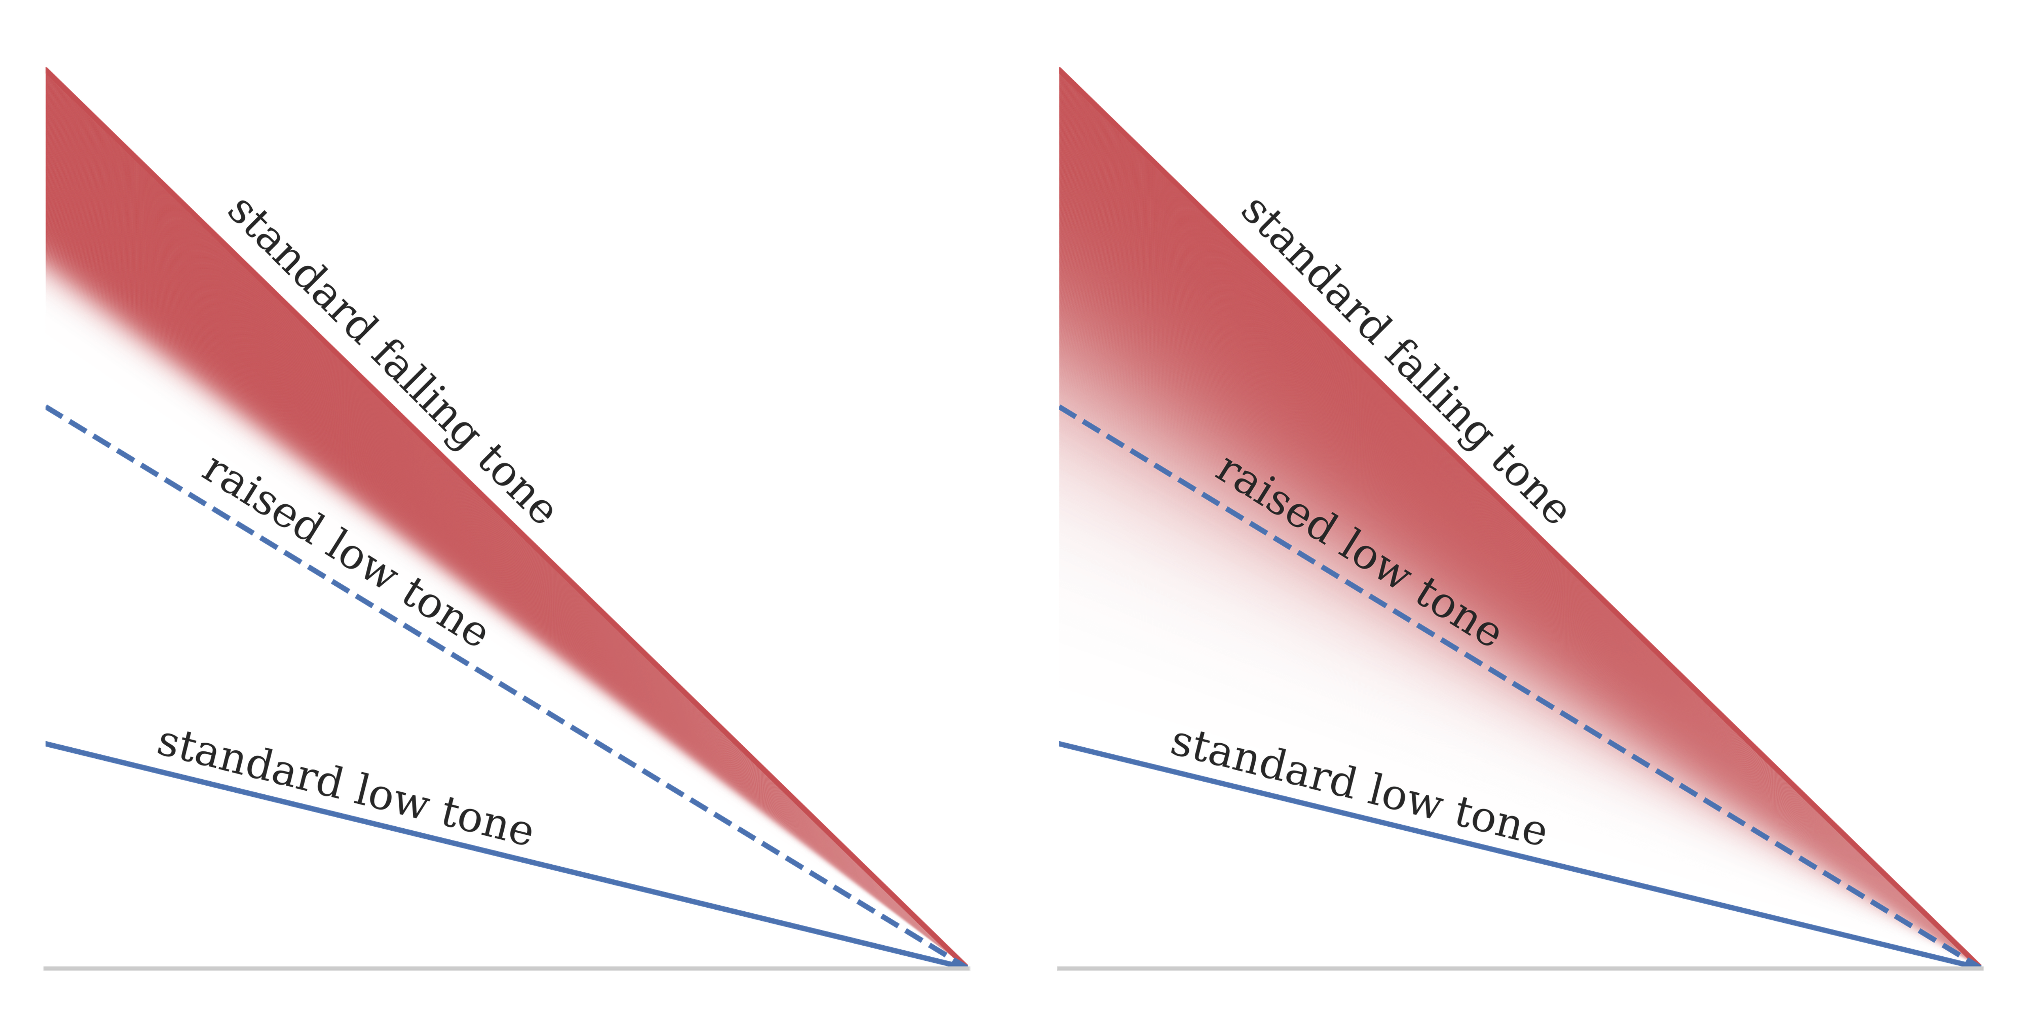
Figure 1. An illustration of narrower (left) and wider (right) tone acceptance ranges of a falling tone. The red areas indicate the acceptance ranges. The darkness indicates the probability of acceptance.

1.4 Tone inventory vs. tonal coarticulation
The current study examines how the aforementioned factors come into play in the context of TM and TSM tonal coarticulation. These two languages serve as good test cases for two reasons. For one, TSM has a larger tone inventory than TM. As such, the same degree of tonal coarticulation (in production) would be subject to a higher possibility of perceptual confusion. TSM is thus expected to have more constrained tonal coarticulation to reduce tone variations. Such coarticulatory avoidance due to inventory size is not a new idea. While no studies thus far have examined the influence of tone inventory size on tonal coarticulation, studies on segmental coarticulation have already shown the effects of inventory size on coarticulation. In Manuel (1990), for example, it has been found that differences in vowel inventory sizes among Shona, Ndebele, and Sotho led to different magnitudes of coarticulation on vowels. Shona and Ndebele, with their simpler vowel inventories, were found to have stronger coarticulation on vowels, whereas Sotho, which has a more crowded vowel space, exhibited weaker coarticulation on vowels. Manuel argues that this was because in a language with a more crowded vowel inventory, coarticulation is less tolerated in order to maintain the phonemic contrast among the vowels: “Together, these assumptions lead to the expectation that, in general, languages will tend to tolerate less coarticulation just where extensive coarticulation would lead to confusion of contrastive phones. (p. 1286).” Similarly, tonal coarticulation has been shown to be affected by structural constraints other than tone inventory size as well. In Brunelle (2009), it was found that Northern Vietnamese, which uses both phonation and pitch to cue tones, had higher degrees of tonal coarticulation as compared to Southern Vietnamese, where only pitch is used. The author argues that such different degrees of coarticulation were led by the need to maintain phonemic contrast among the tones. We therefore have reasons to hypothesize that structural differences in tone inventory sizes may likewise induce similar linguistic differences in tonal coarticulation. Additionally, this larger tone inventory in TSM also leads to lower recoverability of the target tones (the possibility to retrieve the target tones) than TM due to the larger number of potential intended target tones. It is therefore also predicted that retrieving the intended target through perceptual compensation may be more challenging for TSM than TM.
Given the same size of the tone inventory between BM and TM, we predict tonal coarticulation and perceptual compensation in TM to be comparable to BM. On the one hand, in terms of production, the larger tone inventory of TSM may result in more constrained tonal coarticulation (Hypothesis 1). Perceptually, on the other hand, the lower recoverability could also impede the retrieval of target tones through perceptual compensation in TSM. The listeners may resort to narrower tone acceptance ranges to filter out the coarticulated tones, thus maintaining faithful tone perception (Hypothesis 2).
To measure these three parameters (i.e., the magnitude of tonal coarticulation, the magnitude of perceptual compensation, and tone acceptance ranges), one production experiment and two perception experiments were conducted in this study.

2 Experiment 1: the magnitude of tonal coarticulation
As mentioned in the Introduction (Section 1.4), one potential difference between TM and TSM under tonal coarticulation is that TSM may have a weaker magnitude of tonal coarticulation due to the larger and more complex tonal inventory. Therefore, in this experiment, we aim to measure the production of coarticulated tones in TM and TSM. Specifically, we compare 1) the magnitude and 2) the directionality of tonal coarticulation in the two languages.
2.1 Methods

2.1.1 Participants
Forty-three Taiwanese college students (25 females; 20–27 y.o., mean=21.93) were recruited to participate in a production experiment (this experiment) and two perception experiments. Fifteen of them were native speakers of TM. These participants were not speakers of TSM (self-assessed) and are hereafter labeled as the monolingual group. The other 28 participants were bilingual speakers of TM and TSM. While all the bilingual participants self-identified as native speakers of both languages, Taiwan Mandarin is still the dominant language in the Taiwanese society, and is used for lecturing at school. As a result, the fluency in Taiwan Southern Min of younger Taiwanese people varies, depending on how much exposure they have at home and also on the cities they grew up in. As such, fluency scores were also self-reported on a fluency scale from one to ten. Among these bilingual speakers, 11 speakers were advanced TSM speakers, with self-reported scores at the third quartile among the bilingual speakers (i.e., eight) or higher (See Appendix A.1 for the prompts used to elicit the fluency scores).
These 11 speakers were classified as the advanced bilingual group, and the rest of the bilingual speakers were the intermediate bilingual group. No participants were speakers of any other tonal languages. The production experiment only included the monolingual speakers and the advanced bilingual speakers. The intermediate bilingual speakers were excluded due to the potential lack of fluency to complete the production task. The monolingual speakers only participated in the Mandarin section; the bilingual speakers participated in both the Southern Min and Mandarin sections (see below).

2.1.2 Stimuli and recording
To examine the influence of context tones on the target tones, 15 TM disyllabic words (four tones×four tones − 1 [i.e., T3’-T3, due to tone sandhi]) and 25 TSM disyllabic words (five tones×five tones) were designed as stimuli. To better capture the F0 contours, syllables with voiceless plosives, affricates, or fricatives were excluded. Each stimulus required 10 repetitions.
The audio data were collected with a microphone (Audio-Technica Cardioid AT2035) connected to a portable audio interface (USBPre 2), and saved as wave files, with a sampling frequency of 44100 Hz.

2.1.3 Procedure
Before the recording, participants were first familiarized with the word lists, and instructed to read the words at a relaxed and normal speed. The stimuli were then pseudo-randomly presented on slides, where the same stimulus would not be presented twice consecutively. The presentation was self-paced. The TM stimuli were presented in Chinese characters. The TSM stimuli were presented in Chinese characters (top) and Tâi-lô romanization (bottom).

2.1.4 Measurements and analyses
In this study, we measure tonal coarticulation via the coefficient weight of the context tone value predictor in regression models where the dependent variable is the target tone value. This is measured at the boundary of the tone pairs. In the carryover position, we measure the effects of the context (preceding) tone offset on the target (following) tone onset. In the anticipatory position, we measure the effects of the context (following) tone onset on the target (preceding) tone offset. For each tone production, F0 values were extracted with Praat (Boersma and Weenink 2018) and divided into 11 portions. The onset was determined as the F0 mean of the first portion. The offset was determined as the F0 mean of the last portion. For those tokens where F0 values were not successfully extracted by Praat, the second/second last portion was used, or the third/last third, if necessary. If F0 values in all first three or all last three portions were not available, the token was discarded (n=813; 12.51% of the 6,500 tokens elicited). Among the discarded tokens, most were low tones due to creaky voicing. Specifically, we identified that two TM monolingual speakers’ data were largely discarded (80.67% and 48.00%), against a mean per-speaker discard rate of 14.08%. We therefore excluded these two speakers’ data in the final analysis. Within the remaining 23 speakers, 620 of 6,200 elicited tokens (10.00%) had been discarded for tracking failure, leaving 5,580 tokens.
Data were fitted through linear mixed-effects models (LMM) using R Core’s (R Core Team 2023) lme4 package (Bates et al. 2015). In this study, significance was calculated through Satterthwaite’s method with the lmerTest package (Kuznetsova et al. 2017). To examine the effect of tonal coarticulation (how the target tone onset/offset changes with the context tone offset/onset), position (carryover vs. anticipatory), and language (TM [monolingual] vs. TM [bilingual] vs. TSM [advanced]), a maximal model was fitted. The predicted variable was the target tone offset/onset (continuous). The fixed effects were context tone offset/onset (continuous), language (categorical; sum-coded, with TSM represented as the negative sum of the other levels), and position (categorical; effects coded, with anticipatory as −0.5 and carryover as 0.5). Target tone (as surface tone after tone sandhi) identity (categorical; sum-coded, with the high-level (55) tone represented as the negative sum of the other levels) was also included as a controlled variable. It should be reminded that, as TM and TSM share a high degree of overlap in their lexical tone distributions, the inclusion of tone identity is possible and useful for a systematic comparison between the two languages. To account for the potential effects of using the mean values from different portions, portion index was also included as a continuous variable for the context tone and the target tone, with the portion closest to the syllable boundary labeled as 0 and the furthest portion labeled as 2. This was then z-scored within tokens for the reference level to be at the mean. Participant and onset/offset segment type (vowel, liquid, nasal, or obstruent) were taken as the grouping factors for random intercepts and random slopes for tone offset/onset. Follow-up models would be fitted if any interaction was found among context tone offset/onset, language, and position. Considering that several previous studies found inconsistent distributions for different tones (Huang 2013; Jeng 2012; Peng 1997), each tone from TM and TSM was also individually examined with two separate models for the carryover and anticipatory effects, respectively.
Following Chang and Hsieh (2012), coefficient estimates for context tone values (onsets/offsets), with target tone value as the dependent variable, were treated as an indicator of tonal coarticulation. An α-level of 0.05 was used for the significance threshold. Positive coefficient estimates were indicative of assimilatory effects, whereas negative ones were associated with dissimilatory effects. Larger absolute coefficient estimates would indicate stronger magnitudes. As mentioned in the Introduction (Section 1.4), TSM may have more constrained coarticulation than TM under Hypothesis 1, where tone inventory sizes may lead to less/more constrained tonal coarticulation. In this case, an interaction would be found between TM (monolingual) vs. TSM (advanced) and the effects of context tone values on the target tone values. Specifically, such an interaction would be in the opposite direction with the effects of context tone values on the target tone values (i.e., less negative/dissimilatory effects in TSM when the overall coarticulatory effects are negative/dissimilatory; less positive/assimilatory effects in TSM when the overall coarticulatory effects are positive/assimilatory). Alternatively, comparable coarticulation between TSM and TM may be anticipated under Hypothesis 2, where perceptual mechanisms are adapted in lieu of changing production behaviors. This would be indicated by the non-significance of the interaction between TM (monolingual) vs. TSM (advanced) and the coarticulatory effects. Since language was sum-coded, to examine this interaction, we used the emtrends() function from emmeans (Lenth 2021).
Lastly, a small portion of potential outliers were identified through residual analysis. We excluded outliers with absolute residuals larger than 2.5 standard deviations (3.3% of the data; Sonderegger 2023). The models reported below were thus fitted to 10,796 observations from 23 speakers.
To provide a direct qualitative examination of the global effects of tonal coarticulation, aside from regression analyses, we also included generalized additive mixed-effects modeling (GAMM) results that capture the overall F0 trajectories of the tone pairs based on all the 11 points in a contour. This is included in Appendix A.3. The effects of tonal coarticulation on the high tone in TM (monolingual) in the carryover position is shown here as an example (Figure 2), with the gray dashed lines roughly indicating the mid-points where the first/last three portions of the F0 contours were collected.
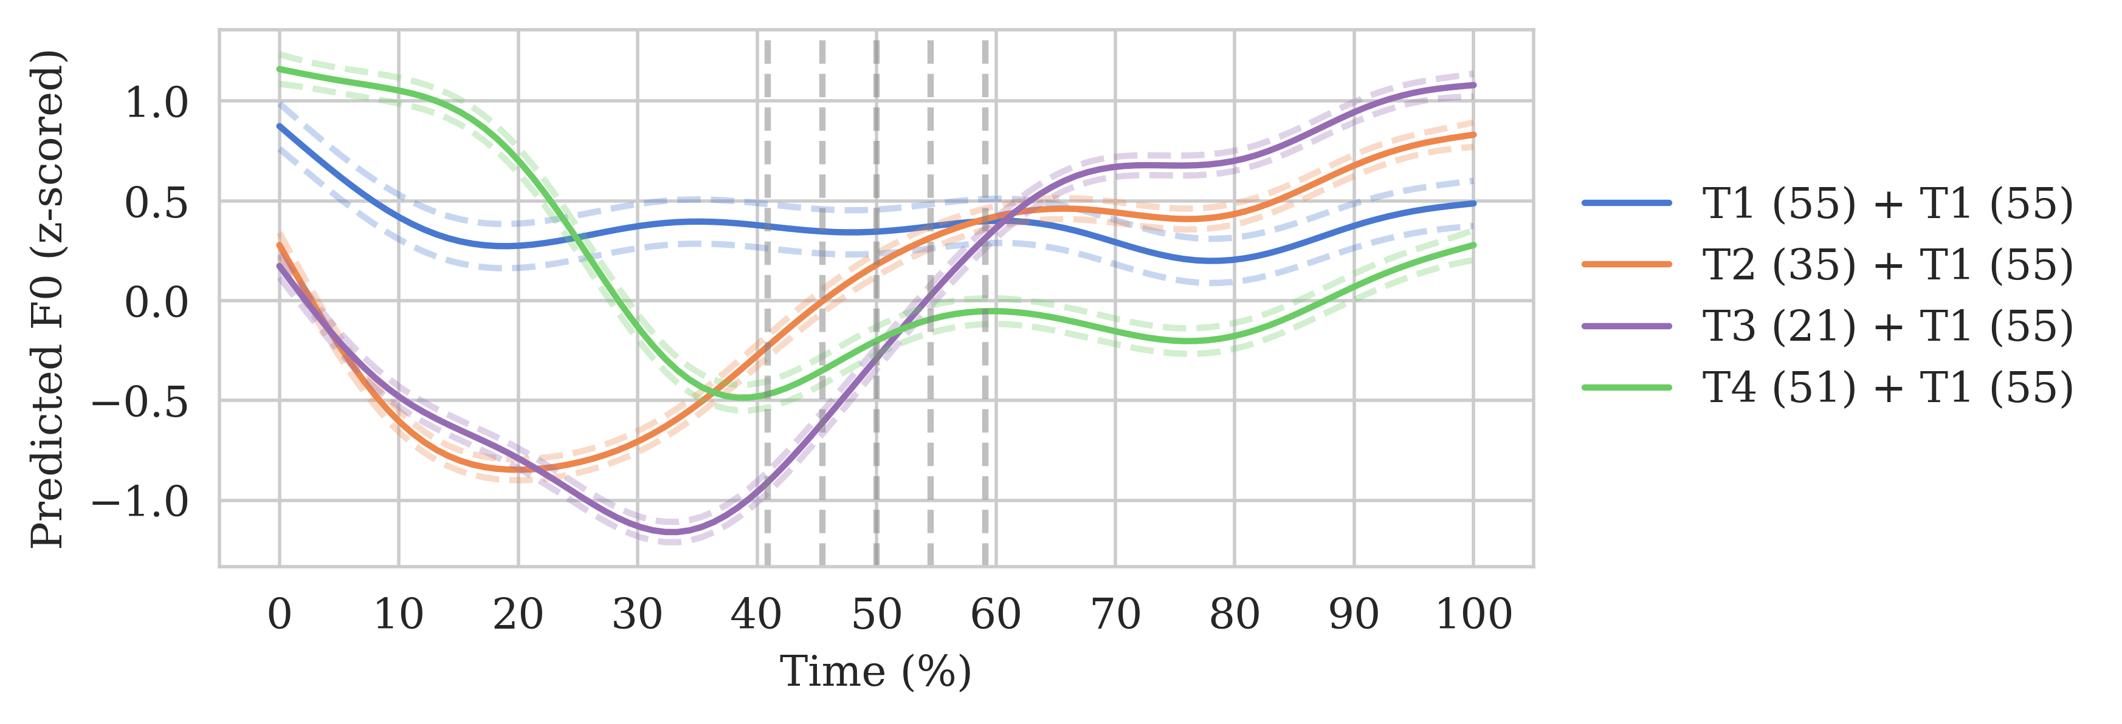
Figure 2. The GAMM results of the tonal coarticulation effects on the high tone in TM (monolingual) in the carryover position. The gray dashed lines roughly indicate the mid-points where the first/last three portions of the F0 contours were collected.

2.2 Results

2.2.1 Examination of tonal coarticulation across positions and languages
The regression table of the maximal model is shown in Table 2. The raw data points of the tone onsets and offsets, along with the predicted trajectories by the LMMs, can be found in Appendix A.4. Visualization of the tone contour trajectories based on generative additive mixed-effects models (GAMM) is also provided in Appendix A.3.
Table 2. Regression table of the maximal model examining the tonal coarticulation effects (only terms of interest, i.e., context tone onset/offset, language, and position, and their interactions are listed).
Effect | Est. (±SE) | t-value | p-value
intercept | −0.123±0.064 | −1.922 | 0.081
context tone onset/offset | 0.320±0.064 | 5.037 | <0.001 | ***
language (contrast 1) | 0.041±0.037 | 1.097 | 0.278
language (contrast 2) | −0.076±0.027 | −2.824 | 0.005 | **
position | 0.248±0.053 | 4.649 | <0.001 | ***
context tone onset/offset:language (contrast 1) | −0.044±0.040 | −1.104 | 0.276
context tone onset/offset:language (contrast 2) | −0.047±0.027 | −1.719 | 0.088
context tone onset/offset:position | 0.203±0.048 | 4.214 | <0.001 | ***
language (contrast 1):position | 0.157±0.047 | 3.326 | <0.001 | ***
language (contrast 2):position | −0.009±0.045 | −0.192 | 0.848
context tone onset/offset:language (contrast 1):position | 0.247±0.044 | 5.603 | <0.001 | ***
context tone onset/offset:language (contrast 2):position | −0.113±0.043 | −2.598 | 0.009 | **
Formula: target tone onset/offset ∼ context tone onset/offset * language * target tone identity * position * target tone onset/offset portion index * context tone onset/offset portion index + (1 + context tone onset/offset | onset segment type) + (1 + context tone onset/offset | offset segment type) + (1 + context tone onset/offset | participant)
Language contrasts: 1 (TM [monolingual]=1, TSM=−1); 2 (TM [bilingual]=1, TSM=−1)
In the LMM results (Table 2), the coefficient estimate for the context tone value is significantly positive ($\hat{β}$=0.320; p<0.001). When the context tone onset/offset was higher, the target tone offset/onset would also be raised. Likewise, lower context tone is also associated with lowered target tone. This suggests that coarticulatory effects were present and that such effects were assimilatory.
In addition, the coarticulatory effects of the context tone values on the target tone values were also found to be influenced by position. The effect of the context tone on target tone values was stronger in the carryover position than in the anticipatory position ($\hat{β}$=0.203; p<0.001). This suggests that compared to the effects of the following tone onsets on the preceding tone offsets (anticipatory effects), the effects of the preceding tone offsets on the following tone offsets (carryover effects) are stronger.
This positional difference was more positive/stronger in TM (monolingual) than the grand mean ($\hat{β}$=0.247; p<0.001), and less positive in TM (bilingual) than the grand mean ($\hat{β}$=−0.113; p=0.009). Follow-up within-language comparison models further showed that this positional difference was only significant for the TM (monolingual) group (TSM [advanced]: $\hat{β}$=−0.040; p=0.463; TM [monolingual]: $\hat{β}$=0.078; p=0.010; TM [bilingual]: $\hat{β}$=0.055; p=0.144). This suggests that while positional differences exist between carryover effects and anticipatory effects in TM (monolingual), such differences were less robust in TSM and TM (bilingual). To examine whether the directionality of tonal coarticulation flips in the anticipatory position in TM (monolingual) due to this positional difference, a follow-up model was conducted. In TM (monolingual), the effects remained assimilatory in both positions (carryover: $\hat{β}$=0.331; p<0.001; anticipatory: $\hat{β}$=0.274; p=0.011).
Lastly, a central question this experiment seeks to answer is whether a difference in tone inventory sizes would lead TSM to have lower magnitudes of tonal coarticulation. As mentioned previously, lower magnitudes of tonal coarticulation can be indicated through a significant interaction between TM (monolingual) vs. TSM (advanced) and the coarticulatory effects. A pairwise contrast of the estimated marginal trends through emtrends(), evaluated at the mean portion index, showed that the effect of context tone value is significantly stronger in TSM than in TM (monolingual) (TM [monolingual]−TSM; $\hat{β}$=−0.139; p=0.025). Within the bilingual speakers, such linguistic differences were likewise attested (TM [bilingual]−TSM; $\hat{β}$=−0.174; p<0.001). Lastly, the magnitude differences were not reliable between TM (monolingual) and TM (bilingual) (TM [monolingual]−TM [bilingual]; $\hat{β}$=0.036; p=0.779).
Taken together, the regression model results suggest: 1) tonal coarticulation (regression coefficient of context tone values for target tone values) exists in the tone pair production produced by the speakers in this experiment, 2) these coarticulatory effects are assimilatory (positive regression coefficient), 3) carryover effects are stronger than anticipatory effects in TM, and 4) the directionality of tonal coarticulation is comparable across language groups, while the magnitude is stronger in TSM.

2.2.2 Comparison of individual tones
While largely comparable results were found for the general patterns of tonal coarticulation across the three language groups, it was observed that different tones had different distributions, especially different magnitudes (cf. Appendix A.4). Six follow-up models from each language group matched with each of the two positions (carryover vs. anticipatory) were therefore fitted. Within each model, the target tone identities were sum-coded, with the high-level (55) tone represented as the negative sum of the other levels. The fixed effects included the context tone onsets/offsets and the target tone identity. The same random structure from the maximal model was used.
To assess whether the effects of context tone values on target tone values varied across different target tones, estimated marginal trends (i.e., the slopes of the context tone values accounting for random effects) were extracted using the emtrends() function from emmeans (Lenth 2021). Post-hoc pairwise comparisons of these trends were then conducted with Tukey’s adjustment for multiple comparisons.
In all six models, the effects of the context tone values on the target tone values remained positive. This suggests that the directionality of the coarticulatory effects is consistently assimilatory in both the carryover and anticipatory positions across the three language groups. The effects of the context tone values, however, became insignificant for the TM (bilingual) group. This may also be due to the smaller number of data points. Post-hoc pairwise comparisons revealed magnitude differences in some of the tone contexts (cf. Appendix A.5). In the pairwise comparisons, tone-specific magnitude differences were found in all three language groups. Specifically, the high-level (55) tone and the rising (35) tone seem to be often subject to weaker tonal coarticulation than the low (21) tone, the mid-level (33) tone, and the falling (51) tone.

2.2.3 The potential effects of different ways of measuring tonal coarticulation
As the distribution of tonal coarticulation is bound by how it is measured, a potential concern is that different measurements could lead to different results.
In this study, we get the mean values of the 11 portions from each trajectory, a number also used in Chang and Hsieh (2012), the only difference being Chang and Hsieh extracted only the raw data points. Mean values were used instead to alleviate the problem of failing to extract F0 or occasional incorrect extraction by Praat. To allow for our analysis to be as generalizable as possible, we also included the portion index in the regression models. As expected, the effects of tonal coarticulation decreased as the selected point moved further away from the syllable boundary (target tone onset/offset portion index: $\hat{β}$=−0.277; context tone onset/offset portion index: $\hat{β}$=−0.115; both p’s<0.001). In addition, the cross-linguistic differences become unreliable (TM [monolingual]−TSM; $\hat{β}$=0.080; p=0.825; TM [bilingual]−TSM; $\hat{β}$=−0.258; p=0.162). This suggests that the cross-linguistic difference does not survive the diminishing coarticulatory effects as the point of evaluation moves away from the boundary.
We note, however, that other measurement methods have also been used in previous studies to examine tonal coarticulation. Overall, there are three common ways of measuring tonal coarticulation. The first, and the most common, is to get the raw/mean F0 values at different temporal points at the contours. This is the measurement used in the current study, as well as Xu (1997), Chang and Hsieh (2012), Huang (2013), Jeng (2012), Lin (1989), Peng (1997), and Wang (2002). The second way is to prespecify the tonal environments (e.g., raising vs. lowering; Huang 2025 or compatible [larger F0 onset-offset change] vs. conflicting [smaller F0 onset-offset change]; Xu 1994), and measure the mean values or the slopes of the F0 contours. Lastly, a global way of measuring tonal coarticulation is to use curve trajectory methods such as generative additive mixed-effects models (Sun and Shih 2021; Burroni and Kirby 2025) or SS-ANOVA (Ren and Mok 2025) to visualize the whole F0 contours. As the last method is principally used as a complementary qualitative analysis, we did not adopt this method. Among the first two methods, we adopted the first one, as it is the most widely used measurement. In the literature, however, the studies that adopt the second method (i.e., Xu 1997; Huang 2025) rendered similar results as the ones that adopt the first method. It is therefore suggested that while the choice of different measurements could potentially lead to different results, the general trends likely still hold.
A summary of the results in this experiment is provided in Table 3. In the next section, we discuss these findings.
Table 3. Summary of the tonal coarticulation results in Experiment 1.
Language group | Directionality | Magnitude
TM (monolingual) | Assimilatory in both positions | Carryover>anticipatory
TM (bilingual) | Assimilatory in both positions | Carryover≅anticipatory
TSM (advanced) | Assimilatory in both positions | Carryover≅anticipatory
Magnitude: TSM (advanced)>TM (monolingual)≅TM (bilingual)

2.3 Discussion
One major finding of the first experiment was that TM and TSM demonstrated rather symmetric (in Chang and Hsieh’s terms) distributions of tonal coarticulation. Both the carryover and anticipatory effects were assimilatory in TM and TSM. The magnitudes of the two types of coarticulatory effects were also rather comparable in TSM. In addition, carryover effects were found to be stronger than anticipatory effects in both the monolingual and bilingual speakers’ TM.
Our findings, especially the directionality results, are therefore largely in alignment with the conclusions of previous studies on TM and TSM. Be reminded that the putative typological distribution suggests that tonal coarticulation is asymmetric, with carryover effects being stronger and assimilatory, and anticipatory effects being weaker and dissimilatory. Our results instead suggest that both TM and TSM serve as counterexamples to the putative typological distribution, exhibiting a generally more symmetric distribution of tonal coarticulation, despite stronger carryover effects in the monolingual and bilingual speakers’ TM. As mentioned in Section 1.1, Chang and Hsieh (2012) propose that the symmetric tonal coarticulation in Malaysian Southern Min could be due to the final prominence coming from Southern Min tone sandhi. As another variant of Southern Min, the symmetry attested in TSM may also be potentially due to such final prominence. On the flip side, the discrepancy between TM and BM may be the result of the long-term interaction between TM and TSM. It has been established that TM and TSM, as the two frequently used languages in Taiwan, have mutual influence on each other, attested in different linguistic levels, including both phonology and phonetics, among others (cf. Chuang and Fon 2010; Li 2010). Such mutual interaction may further influence the distribution of tonal coarticulation in TM. This, however, would require further investigation.
It should also be noted that while the general distributions of tonal coarticulation in TM and TSM are symmetric, individual tone differences exist for anticipatory effects (cf. Appendix A.5). Such a finding has also been found in previous studies of TM (Huang 2013; Jeng 2012) and TSM (Peng 1997). It is worth noticing that it was the high (55) tone and the rising (35) tone that were subject to weaker effects. In Xu (2001), the peaks of the rising tones and occasionally the high tones in Mandarin were found to be delayed to the following syllable, potentially due to biomechanical constraints of the vocal fold and laryngeal movements. In the anticipatory position, such peak delays might well contribute to the weaker assimilatory effects observed in the results, which may not be contributed by tonal coarticulation per se. Such an account, however, cannot explain why the high-level tone is less susceptible to coarticulation even in the carryover position, where it is the following tone, not the preceding tone. An overall observation of the individual tone differences seems to suggest a distinction between the general high tones (high-level and rising tones) vs. the non-high tones (falling and low tones). This high-offset vs. low-offset tone distinction aligns with the tone-specific distinction found in BM by Huang (2025). The effects, however, were the opposite. In BM, the high-offset tones are more subject to tonal coarticulation, while in the current study, they are less affected by the context tone values. This could well be due to the position of the target. In Huang (2025), the target is the second syllable in a tri-syllabic word, which is a prosodically weaker position (Hao et al. 2018). Alternatively, this could also be a language-specific difference. Future studies may be required to see whether a typological distinction exists between these two general tone types.
Lastly, a finding more crucial to the tenet of this study is that tonal coarticulation in TSM was not found to be weaker than TM. In fact, in the present analysis, the magnitude of tonal coarticulation was stronger in TSM than in TM, though such a difference was not reliable when the effects were estimated further away from the boundary. This is, therefore, contrary to the prediction that a larger tone inventory would lead to more constrained coarticulation. Given that TSM had a larger tone inventory than TM, the odds of confusing one lexical tone with another could potentially be higher for TSM than for TM. The magnitudes of tonal coarticulation in TSM and TM are thus more compatible with the conception that tonal coarticulation is a universal constraint on the production level, which cannot be conditioned by phonological contrasts (This, however, requires further scrutiny, as will be discussed in Section 5.2). If tonal coarticulation is consistent for languages with different sizes of tone inventory, successful identification and accurate perception of coarticulated tones (i.e., the perceptual compensation for tonal coarticulation) is then predicted to be language-dependent under Hypothesis 2. While both languages may apply perceptual compensation, due to the aforementioned lower recoverability in TSM, the magnitude of perceptual compensation for tonal coarticulation is predicted to be lower in TSM than in TM. In contrast, TSM may have to resort to other mechanisms, such as maintaining stricter tone boundaries to filter out the coarticulated tones. The next two experiments will investigate how TM and TSM listeners perceive and identify coarticulated tones.
3 Experiment 2: perceptual compensation for tonal coarticulation
As seen in Experiment 1, both TM and TSM show robust tonal coarticulation. This therefore disfavors our first hypothesis proposed in Section 1.4, that is, compared with TM, the larger and more complex tone inventory in TSM may lead to a weaker magnitude of tonal coarticulation in favor of phonological contrasts. Regardless, we are left with another possibility, that is, such a difference in tonal inventory may be reflected on the perceptual level. To address this issue, Experiments 2 and 3 seek to compare 1) the degree of perceptual compensation for tonal coarticulation and 2) the tone acceptance ranges in TM and TSM, respectively.
As proposed in Section 1.4, a larger and more complex tonal distribution and the subsequent larger number of potential candidates could urge TSM to avoid perceptual compensation, therefore leading to a smaller degree of perceptual compensation. In this experiment, we measure and compare the degrees of perceptual compensation for tonal coarticulation in the two languages.

3.1 Methods

3.1.1 Participants
All 43 participants in Section 2.1.1 participated in the perceptual compensation experiment. The monolingual TM speakers only participated in the TM version; the bilingual TSM speakers participated in both the TM version and the TSM version. For the monolingual speakers, Experiments 2 and 3 were performed after Experiment 1. For the intermediate bilingual speakers, the TM versions of Experiments 2 and 3 were conducted first, then the TSM versions. For the advanced bilingual speakers, the TM versions of the three experiments were carried out first, followed by the TSM versions. Experiments 1 and 2 were done with a 10-minute break in between. Experiments 2 and 3 were done with a minimal 1-minute break in between.

3.1.2 Stimuli
Three pairs of TM disyllabic words and four pairs of TSM disyllabic words were chosen as stimuli. These pairs were minimal pairs that only differed in the tones of the second syllables, and were completely identical on the segmental level. For each pair, the first syllables were consistent and served as the preceding contexts, and the second syllables were the targets, matched with either a low tone or a falling tone, following Zhang et al.’s (2022) design. In the TM version, T3 (21) was excluded due to tone sandhi, leaving only T1 (55), T2 (35), and T4 (51) as the preceding tones. In the TSM version, T2’ (35) was also excluded since not all dialects apply such a sandhi rule, leaving only T2’ (55), T5’ (33), and T3’ (51), T7’ (21) as the preceding tones. See Appendix B.1 for the full list of the words used.
These words were produced by one male TM native speaker (25 y.o.) and one male TSM native speaker (24 y.o.). Recording was conducted using the same apparatus as Experiment 1. Following Zhang et al. (2022), the recordings were synthesized into continua with the preceding context staying the same and the F0 values of the target ranging from a low contour to a falling contour, with 10 steps in between (see Figure 3).
Disyllabic words were produced naturally by the model speakers and then excised into separate syllables using Praat (Boersma and Weenink 2018). The F0 contours of the preceding contexts were synthesized with Praat, based on the calculated corresponding F0 values at the five-level tone scales, following Fon and Chiang’s (1999) equation in Eq. (1):
$scale=\frac{1}{2}(39.86×log\frac{f_{i}}{f_{min}})+1$ (1)
In this study, f_{min} was set at 100 Hz. This was approximately the lowest pitch of the two model speakers in their natural utterances. The converted F0 values from the scales one to five were 100, 112.25, 125.99, 141.43, and 158.75 Hz. The F0 contour for each preceding context was interpolated linearly from the corresponding starting frequency to the corresponding ending frequency. For example, a rising (35) tone value on the five-level scale is translated into a contour starting at 125.99 Hz and ending at 158.75 Hz.
The F0 contours of the targets were determined as follows. The starting F0 values of the targets were divided into 10 levels on the Bark scale, with a minimum of 0.9, a maximum of 1.9 on the Bark scale, and a step interval of 1/9. All the ending F0 values were set to be at the minimum (i.e., 0.9). As such, a continuum going from a low F0 contour to a falling F0 contour was created. The corresponding F0 values of these 10 levels in Hz were: 90.34, 101.59, 112.88, 124.2, 135.57, 146.99, 158.45, 169.97, 181.55, and 193.19, respectively.
Aside from F0 values, all other suprasegmental properties of the preceding contexts and targets were set to be identical. The average intensities were all scaled to be at 65 dB, and the duration of each syllable was set at 0.3 second by speeding up/down the audio, using FFmpeg (Tomar 2006). The synthesized syllables were then concatenated back into a single audio file with Python’s wave package.
Together, each preceding context and target pair was combined into a 0.6-second-long disyllabic stimulus. See Figure 3 for illustration. All stimuli have been checked auditorily by the first author to ensure the naturalness of the stimuli.
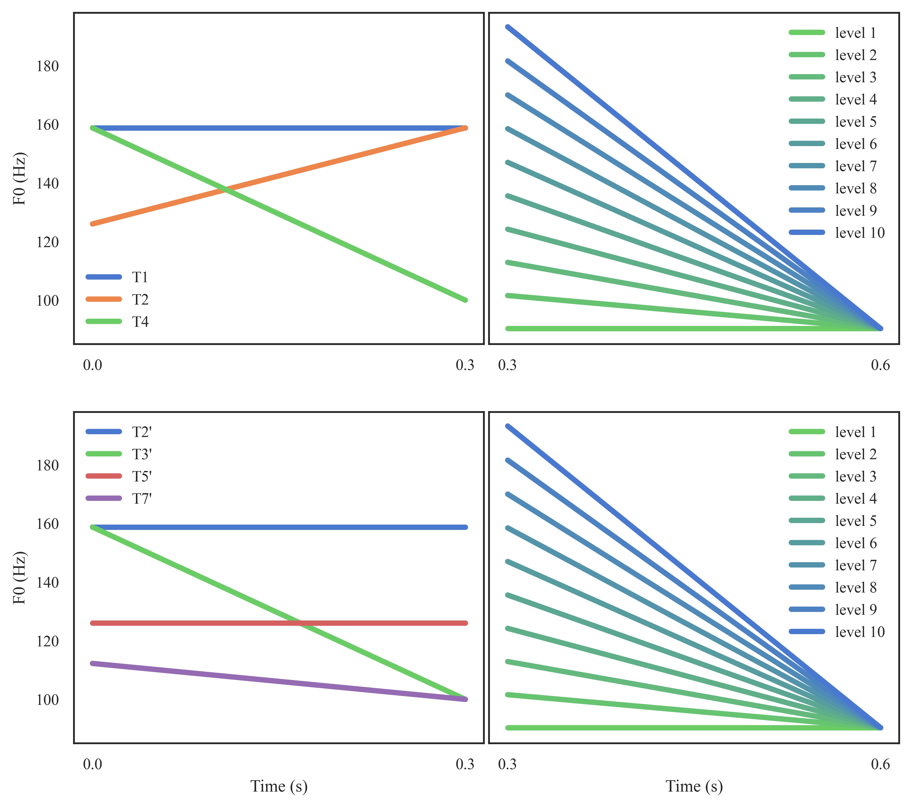
Figure 3. Illustrations of synthesized pitch contours (top: TM; bottom: TSM). The preceding contexts are presented on the left (blue: high-level [55]; green: falling [51]; orange: rising [35]; red: mid-level [33]; purple: low [21]). The targets of 10 levels are presented on the right; ranging from a low tone (green) to a falling tone (blue).

3.1.3 Procedure
In Experiments 2 and 3, PsychoPy (Peirce et al. 2019) was used to present the stimuli and record the participant’s responses. In each trial, participants would first see a fixation cross, lasting for one second. Immediately after that, a picture of an ear and the auditory stimulus were presented simultaneously. After another inter-stimulus interval of 0.4 second, a target minimal pair would appear. Participants were instructed to identify the word they heard by clicking on it. The trial ended upon the click, immediately followed by the next trial. For the TM section of the experiment, the words were presented in traditional Chinese; for the TSM section, both the traditional Chinese characters and their romanizations were presented. Stimuli were pseudo-randomly shuffled so that no words in the same pair would appear in two consecutive trials.
For the TSM version, to ensure participants were familiar with the stimuli, slides with the orthographies of the stimuli, illustrative pictures, and the associated word meanings were presented before the practice and formal trials. This familiarization phase took no more than 2 minutes for all participants. Experiment 2 took around 10 minutes for each participant.

3.1.4 Analyses
To examine how the level of the second tone (ranging from the most low-tone-like to the most falling-tone-like), the preceding tone, and the language would jointly affect participants’ choice between falling tones and low tones, a mixed-effects logistic regression model was fitted using the lme4 package (Bates et al. 2015).
The responses were coded as 1 (falling tone response) and 0 (low tone response), and taken as the predicted variable. Three variables and their interactions with language (categorical; dummy coded, with separate contrasts for TM [monolingual] vs. TSM and TM [monolingual] vs. TM [bilingual]) were taken as the predictors. Firstly, the level of the second tone was treated as a continuous predictor (i.e., 1, 2, 3, 4, 5, 6, 7, 8, 9, 10). Secondly, the preceding tones were first converted to five-level tone values (as the 21, 33, 35, 51, 55 tones), and the offsets of these values (i.e., 1, 3, 5, 1, 5) were treated as another continuous predictor in the model. We note that the relationship between a preceding tone and the perception of the following tone in perceptual compensation may not be simply modulated by the preceding tone offset values. Indeed, a previous study (Zhang et al. 2022) reported that tones with the same offsets (e.g., Mandarin T1 [55] and T2 [35]) induced different degrees of perceptual compensation, with the T2 (35) tone inducing an even higher degree of compensation. Therefore, to account for this potential tone-specific difference (i.e., the categorical effects), the identities of the preceding tones (i.e., the low (21), mid-level (33), rising (35), falling (51), high-level (55) tones) per se were included as the third predictor (categorical; sum-coded with the high-level (55) tone represented as the negative sum of the other levels). As such, the magnitude of perceptual compensation was measured as the low-falling tone distinction as a function of the preceding tone offset, while also accounting for the potential tone-specific differences. Since in the model, only two tones (falling and high-level) were shared among the two languages, including all tones in the model would lead to certain terms being dropped (see footnote 26). To examine a more concise model where no terms were dropped, we also fitted another model where only the falling and high-level tones were examined. These are called the comprehensive model and the concise model.
The entire fixed effects included these terms (with level and preceding tone offset centered), their interactions with language, and the main effects of languages. Participant was considered as the grouping factor for the random intercepts.
Lastly, to account for the frequency effects of the stimuli, the frequencies of the TM and TSM stimuli were extracted from the Academia Senica Balanced Corpus (Huang and Chen 1992) and the TAT MOE Corpus (Liao 2022). The frequency ratios between the preceding tone+falling (51) tone vs. preceding tone+low (21) tone minimal pairs (i.e., frequency of the preceding tone+falling tone word/frequency of the preceding tone+low tone word) were then log-transformed and standardized. A higher ratio indicates a relatively higher frequency of the falling tone stimulus compared to its low tone counterpart in the minimal pair. However, since for each stimulus in each language, the frequency count was unique, a direct inclusion of the frequency ratios in the regression model would induce ranking deficiency. To resolve this, we calculated the Pearson’s correlations of the frequency ratio with both the falling tone response (the predicted variable) and the preceding tone offset (the main predictor). The correlations of the frequency ratio with both variables were fairly low and negligible (the falling tone response: r=0.036; the preceding tone offsets: r=0.125). This suggests that the frequency ratio likely did not have much effect on the attested trends. Post-hoc regression analyses were also conducted to check the potential explained variance between the residuals of the fitted model and the frequency ratio. The effects of the frequency ratio were confirmed to be non-significant ($\hat{β}$=0.004; p=0.521).
In this study, the influence of the preceding tone offset on the falling tone choice would be treated as an indicator of the magnitudes of perceptual compensation for tonal coarticulation (i.e., how much perceptual compensation is induced in response to tonal coarticulation). If a language has strong perceptual compensation for tonal coarticulation, the participants’ perception of the same target tone would be subject to the pitch height of the preceding tone offset, therefore rendering a lower (preceded by a higher pitch offset) or higher (preceded by a lower pitch offset) possibility of the falling tone response.

3.2 Results
A visualization of the falling tone response across levels and following different preceding tones is shown in Figure 4. As expected, the participants were more likely to give a falling tone response as the level of the tone onset increased. Specifically, the preceding tone before the target seemed to affect the rates of the target being taken as a falling tone vs. a low tone.
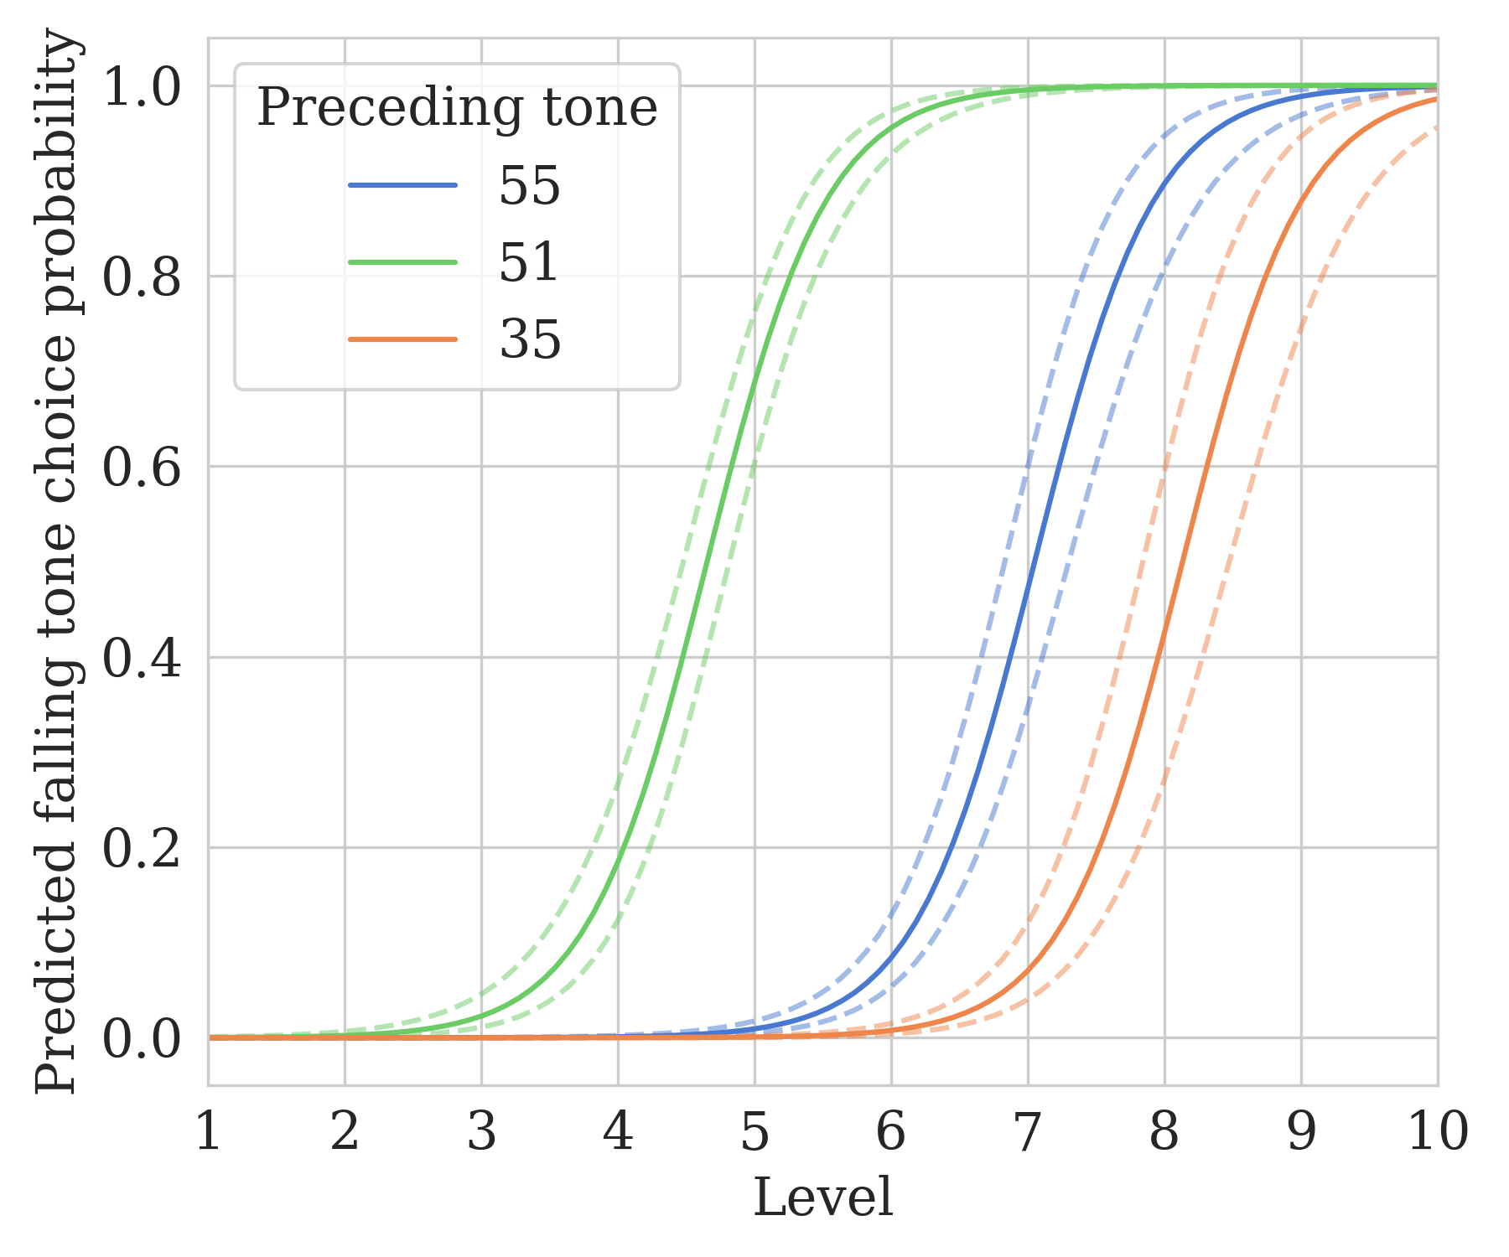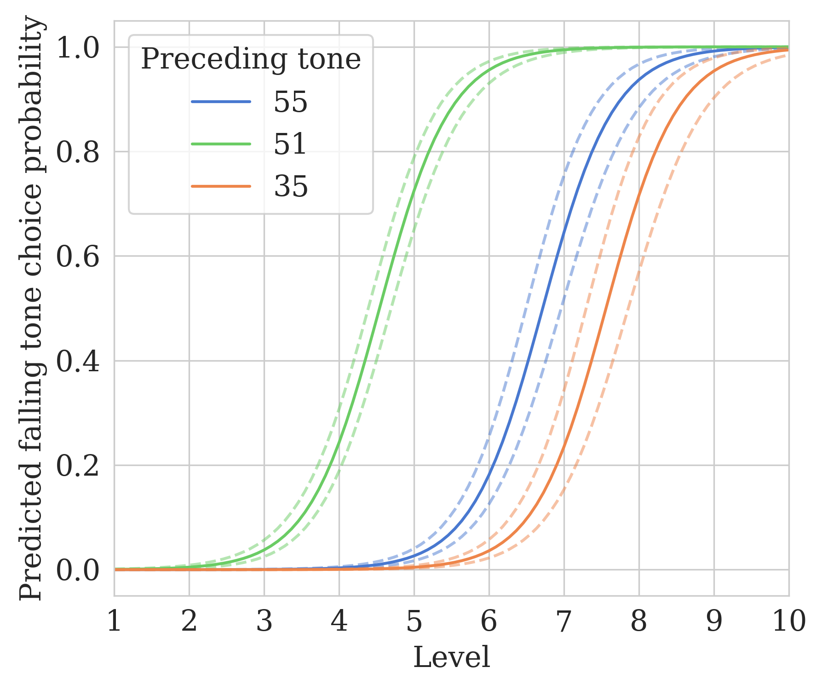
(a) (b)
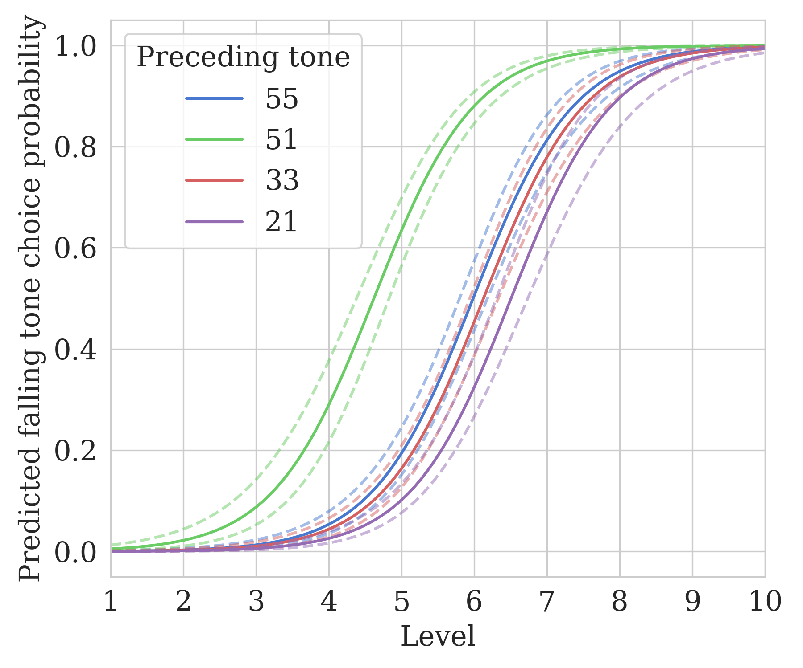
(c)
Figure 4. Logistic regression fits of falling tone response across different preceding tones (a: TM [monolingual]; b: TM [bilingual]; c: TSM). Dashed lines indicate confidence intervals.
The logistic regression results from the concise and comprehensive models are shown below in Tables 4 and 5.
Table 4. Regression table of the logistic mixed-effects model.
Effect | Est. (±SE) | z-value | p-value
intercept | −1.081±0.211 | −5.125 | <0.001 | ***
level | 2.893±0.218 | 13.272 | <0.001 | ***
language (TM [bilingual]) | 0.725±0.248 | 2.918 | 0.004 | **
language (TSM) | 1.433±0.245 | 5.844 | <0.001 | ***
preceding tone offset | −1.792±0.151 | −11.882 | <0.001 | ***
level:language (TM [bilingual]) | −0.903±0.235 | −3.844 | <0.001 | ***
level:language (TSM) | −1.354±0.226 | −5.997 | <0.001 | ***
language (TM [bilingual]):preceding tone offset | 0.675±0.164 | 4.118 | <0.001 | ***
language (TSM):preceding tone offset | 1.214±0.157 | 7.747 | <0.001 | ***
Formula: falling tone chosen ∼ level * language + preceding tone offset * language + (1 | participant)
Table 5. Regression table of the logistic mixed-effects model. Effect | Est. (±SE) | z-value | p-value
intercept | −2.190±0.184 | −11.920 | <0.001 | ***
level | 2.044±0.109 | 18.814 | <0.001 | ***
language (TM [bilingual]) | 0.854±0.243 | 3.511 | <0.001 | ***
language (TSM) | 1.148±0.212 | 5.400 | <0.001 | ***
preceding tone offset | −1.865±0.097 | −19.276 | <0.001 | ***
preceding tone (contrast 1) | −2.573±0.149 | −17.249 | <0.001 | ***
preceding tone (contrast 2) | 0.068±0.103 | 0.655 | 0.512
preceding tone (contrast 3) | 0.117±0.180 | 0.651 | 0.515
level:language (TM [bilingual]) | −0.248±0.126 | −1.974 | 0.048 | *
level:language (TSM) | −0.809±0.113 | −7.151 | <0.001 | ***
language (TM [bilingual]):preceding tone offset | 0.439±0.130 | 3.387 | <0.001 | ***
language (TSM):preceding tone offset | 0.802±0.096 | 8.379 | <0.001 | ***
language (TM [bilingual]):preceding tone (contrast 1) | 0.714±0.312 | 2.288 | 0.022 | *
Preceding tone contrasts: 1 (low [21] tone=1; high-level [55] tone=−1); 2 (mid-level [33] tone=1; high-level [55] tone=−1); 3 (rising [35] tone=1; high-level [55] tone=−1); 4 (falling [51] tone=1; high-level [55] tone=−1)
Formula: falling tone chosen ∼ level * language + preceding tone offset * language + preceding tone identity * language + (1 | participant)

Overall, both models report comparable results. As expected, there exists a positive effect of the level of the target (second) syllable in the stimulus on the participants’ falling tone response (concise: $\hat{β}$=2.893; p<0.001; comprehensive: $\hat{β}$=2.004; p<0.001). When the target tone went from more low-tone-like (lower level) to more falling-tone-like (higher level), participants were more likely to perceive the target as a falling tone.
Specifically, the same perceptual compensation effects seen in Zhang et al. (2022) were borne out in the results. A negative regression effect of the preceding tone offset on the participants’ falling tone response was found (concise: $\hat{β}$=−1.792; p<0.001; comprehensive: $\hat{β}$=−1.865; p<0.001). When a target tone was preceded by a higher tone offset, the participants tended to perceive it as a low tone. On the flip side, when a lower tone offset preceded the target tone, the target was more likely to be taken as a falling tone.
More importantly, linguistic differences were attested between both TM (monolingual) participants and TSM speakers, as well as between the monolingual and the bilingual participants’ TM. Firstly, while all three language groups demonstrated rather categorical perception on the low-tone-to-falling-tone continuum (Figure 4), the bilingual participants’ responses were less categorical (Figure 4b), compared to the monolingual speakers (Figure 4a; as indicated by the negative interactions between the level and both TSM and TM [bilingual]; concise: TSM: $\hat{β}$=−1.354; p<0.001; TM [bilingual]: $\hat{β}$=−0.903; p<0.001; comprehensive: TSM: $\hat{β}$=−0.809; p<0.001; TM [bilingual]: $\hat{β}$=−0.248; p=0.048). This — as will also be discussed in the next experiment — may be attributed to the tone sandhi process in TSM, where the low tone is realized as a falling tone (cf. Appendix D). This alternation could reduce the categorical distinction between the two tones in TSM, thereby influencing the bilingual participants’ perception in TM.
In addition to the difference in categorical distinction, the main focus of this experiment is to observe where linguistic differences lie in the perceptual compensation between TM and TSM. Our results show that while there was a negative effect of the preceding tone offset on the falling tone response (perceptual compensation), this effect was less pronounced in TSM (concise: $\hat{β}$=1.214; p<0.001; comprehensive: $\hat{β}$=0.802; p<0.001) and TM (bilingual; concise: $\hat{β}$=0.675; p<0.001; comprehensive: $\hat{β}$=0.439; p<0.001), as indicated by the positive coefficients of the preceding tone offset with these two language groups. This suggests that, compared to the baseline (TM), the negative effect of the preceding tone offset on the falling tone response was less robust in TSM and TM (bilingual).
To compare whether there also existed a difference in the magnitude of perceptual compensation within the bilingual participants when they were perceiving the TSM vs. TM tones, a follow-up regression model was conducted on the bilingual participants’ responses only. The results revealed that although the bilingual participants exhibited less perceptual compensation when perceiving both TSM and TM tones, TM tone perception was still more susceptible to perceptual compensation than TSM tone perception (concise: $\hat{β}$=0.538; p<0.001; comprehensive: $\hat{β}$=0.566; p<0.001).
Lastly, in Zhang et al.’s (2022) BM study, the rising (35) tone was found to induce a much larger degree of perceptual compensation, compared to the high-level (55) tone. This suggests a potential tone-specific difference that cannot be entirely accounted for by their tone offsets alone. Therefore, the preceding tone identity was also included in our model. However, the only contrast that was found to be significant in the comprehensive model was the one between the low (21) tone and the high-level (55) tone ($\hat{β}$=−2.573; p<0.001), while the contrast between the rising (35) and the high-level (55) tones was not significant ($\hat{β}$=0.117; p=0.515). This could suggest that this contrast is not as robust in our data, and that more power may be required if there is a difference between the two tones’ influence on perceptual compensation. We did, however, see an effect of the low (21) tone that could not be explained by its offset alone. We see that in TSM, as also indicated by Figure 4c, the low (21) tone as the preceding tone did not increase, but reduced the falling tone response. Once again, this may be a bilingual influence. In TM’s tone sandhi, a low tone becomes a rising tone before another low tone. As such, for TSM speakers who are also a speaker of TM, a consecutive low-low tone sequence could be illusorily perceived as a rising-low tone sequence. This, then, could explain why the perception of the target tone with a preceding low tone patterns similarly with the perception when it was preceded by the high-offset-ending high tone and rising tone. Although the stimuli were in TSM and not TM, influence from TM may still play a role.
Overall, the results in this experiment revealed that while perceptual compensation for tonal coarticulation exists in both TM and TSM, it is of a smaller magnitude in TSM than in TM. In addition, this linguistic difference, interestingly, was present not only between groups but also within the bilingual participants when perceiving different languages.

3.3 Discussion
Our experiment replicated the findings of Zhang et al. (2022). When the preceding context ended with a low tone offset (i.e., the falling 51 tone), the target tones were most prone to be perceived as falling tones. Alternatively, when the preceding context ended with a high F0 offset (i.e., a high-level [55] or rising [35] tone), the target tones were likely to be recognized as a low tone.
More crucially, our predictions for perceptual compensation for the two languages were borne out. Linguistic differences were found between TM and TSM. While TSM, as suggested in Wang (2002), demonstrated a certain degree of perceptual compensation in the face of tonal coarticulation, it was to a much lesser extent as compared with TM. In other words, when perceiving tones, TSM speakers may rely less on perceptual compensation to overcome the possible perceptual confusion caused by tonal coarticulation. This appears to be a plausible account if we consider the fact that TSM has a larger tone inventory than TM, and that a coarticulated tone can have a larger number of potential intended target tones for a listener to map back to through perceptual compensation. This limitation of recoverability may account for why we did not see a comparable perceptual compensation effect in TSM as we did in TM, despite the fact that TSM showed stronger magnitudes of tonal coarticulation in Experiment 1 (though see Section 5.4.4 on the fixed task order). The presence of tonal coarticulation and the weaker reliance on perceptual compensation to cope with such coarticulation suggest that TSM may have to resort to other means to cope with the tone variations induced by tonal coarticulation. In the next experiment, we explore the potential difference between TM and TSM regarding tone acceptance ranges.

4 Experiment 3: tone acceptance range
As seen in Experiment 2, the first part of our second hypothesis is borne out: TM has a larger degree of perceptual compensation for tonal coarticulation than TSM. In this experiment, we examine an alternative mechanism other than perceptual compensation: tone acceptance ranges. As mentioned in Section 1.4, a potential perceptual mechanism other than perceptual compensation that a listener can use to counter the variations induced by tonal coarticulation is to keep a stricter acceptance range for a certain lexical tone. For instance, when the onset of a low (21) tone is raised by the preceding tone, a listener may accept it as a falling (51) tone, and later recover the target low tone based on the tonal context (i.e., perceptual compensation). Alternatively, the listener can also reject it as a good falling (51) tone, and still perceive it as the original low (21) tone. In this case, perceptual compensation would be less crucial.
In this experiment, we seek to compare the tone acceptance ranges for the low (21) tone and the falling (51) tone in TM and TSM.

4.1 Methods

4.1.1 Participants
All the same 43 participants participated in the tone acceptance range experiment.

4.1.2 Stimuli
Ten disyllabic words in TM and nine disyllabic words in TSM were selected and used as stimuli. For each disyllabic word, the first syllable was always a high-level (55) tone, whereas one group of the stimuli had a falling tone as their second syllables (the 55+51 group), and the other group had a low tone (the 55+21 group). Two sets of stimuli were designed for each language. The design of these stimuli was to create a continuum from a falling tone to a low tone, where only one of the two ends is associated with a true word and the other is not. The TM 55+51 and 55+21 groups and the TSM 55+51 group had five words. The TSM 55+21 group had four. See Appendix C.1 for the full list of the words used.
These words were produced by the same model speakers as in Experiment 2, and recorded and synthesized into continuums with 10 levels, following the same protocols in Experiment 2.
For each group (low tone vs. falling tone as the target), each level of stimuli was repeated for 10 tokens. For each repetition, one of the disyllabic words for the target tone was fully randomly chosen. Trials were then represented pseudo-randomly so that the same word did not occur in two consecutive trials. A total of 200 (2 groups×10 levels×10 repetitions) stimuli were created.

4.1.3 Procedure
This experiment was conducted immediately after the perceptual compensation experiment, after a minimal one-minute break. The procedure and presentation were the same as Experiment 2, except that only one word was presented in the middle of the screen. Participants were asked to decide whether the presented stimulus was the word on the screen by clicking on the circle (for positive responses) or the cross (for negative responses). The familiarization followed the same procedure as in Experiment 2. Experiment 3 took around 10 minutes for each participant.
4.1.4 Analyses
To make direct comparisons, the low-tone-to-falling-tone levels were first converted to non-word-to-word levels (i.e., 1, 2, 3, 4, 5, 6, 7, 8, 9, 10). The participants’ responses were coded by acceptance (0 or 1). In this experiment, two parameters were measured. One was the steepness of the acceptance. A steeper acceptance change would indicate a stricter tone acceptance boundary for accepting ambiguous tones as good word tokens. Two representative examples are provided in Figure 5. For each participant, a Bayesian mixed-effects logistic regression was fitted. The predictors were level, tone (categorical; dummy coded with low tone=0 and falling tone=1), and word frequency (extracted from the same corpora as in Experiment 2), with random intercepts grouped by word identity. This model structure was adapted to account for the potential word-specific idiosyncrasies and frequency effects, a similar concern as Experiment 2. The steepness of the acceptance rate was then operationalized as the marginal trend (slope) of the level effect on the logit scale, estimated via the emtrends() function from emmeans (Lenth 2021). If the acceptance is associated with a steeper slope (Figure 5b), it would suggest a clearer cut between two ambiguous tones, as in categorical perception.
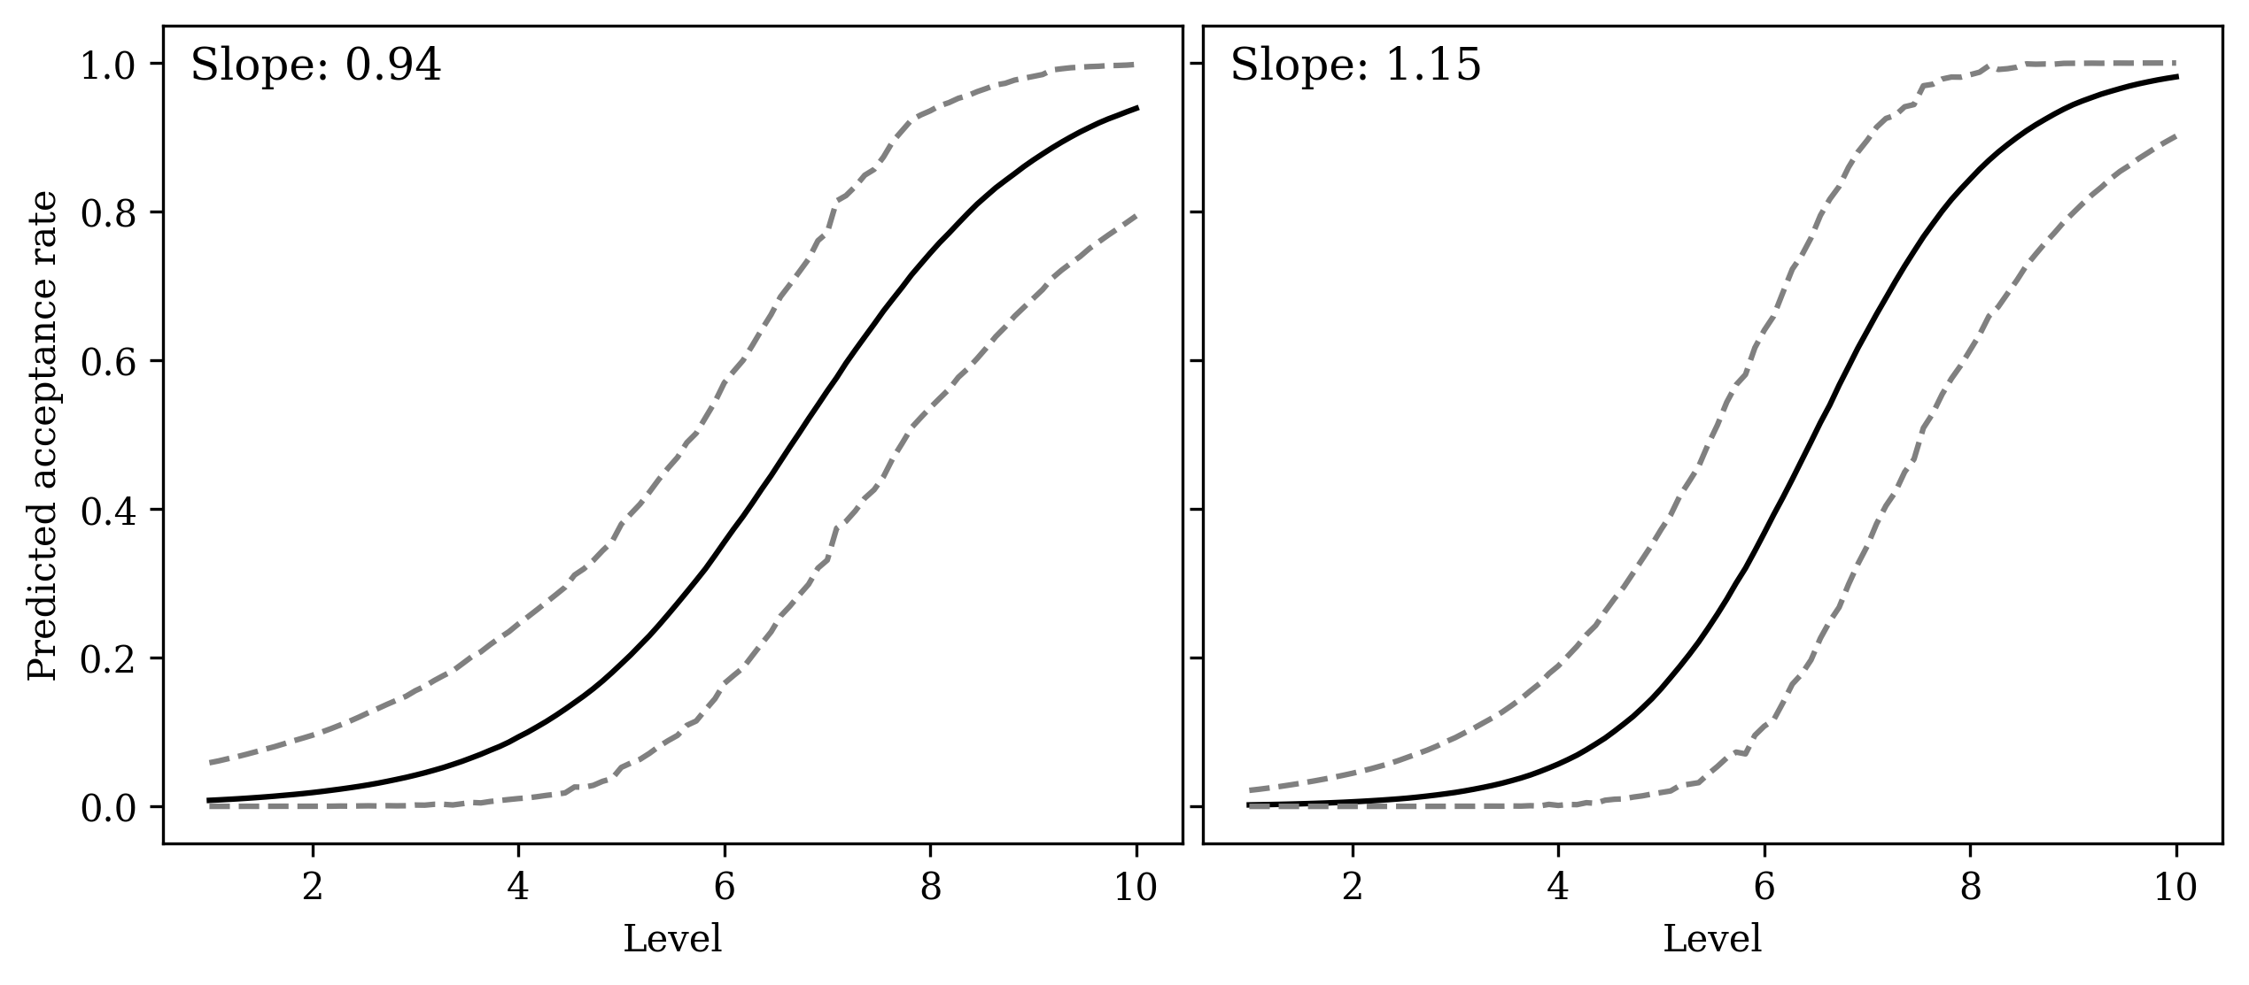
(a) (b)
Figure 5. Representative examples of fitting mixed effects logistic regressions on the acceptance rates of the target tone as a falling tone from two participants (P3; a) and (P15; b) during the Taiwan Mandarin block.

The other parameter is the threshold of acceptance. Following previous studies (Chen and Peng 2016; Huang and Holt 2009; Zhang et al. 2022), this was determined with the probit analysis (Finney 1971). As in the calculation of steepness, a Bayesian mixed-effects probit regression model was fitted for each participant, with the same model formula. In this experiment, the cutoff probability for determining the threshold was set at 0.5. The determined threshold indicated the boundary where an ambiguous tone was accepted as the target tone. A higher-level threshold requires an ambiguous tone to be closer to a canonical tone in order to be accepted.
For each participant, therefore, four measurements were collected: two measurements of the steepness of acceptance rates (one for each of the two target tones) and two measurements of the thresholds of acceptance (also one for each of the two target tones).
For both parameters, a maximal linear mixed-effects model was built to examine the potential differences among the three language groups and the target tones through the lme4 package (Bates et al. 2015). In the models, the parameters (the steepness of acceptance rates and the threshold of acceptance) were treated as the predicted variables. Language (categorical; dummy coded, with separate contrasts for TM [monolingual] vs. TSM and TM [monolingual] vs. TM [bilingual]), target tone (categorical; effects coded, with the low tone as −0.5 and the falling tone as 0.5), and their interaction were treated as the predictors. Participant was treated as the grouping factor for random intercepts. Follow-up models were used to examine any interactions found between languages and target tones.

4.2 Results
4.2.1 Steepness of acceptance rate
The distribution of the steepness of acceptance rate for the two target tones among the three language groups is shown in Figure 6. Overall, we see opposite patterns in TM and TSM between the perception of the low tone and the falling tone. When the target was the low tone, TM speakers seemed to have steeper acceptance rates; when the target was the falling tone, the TSM speakers’ acceptance rates seemed to be steeper.
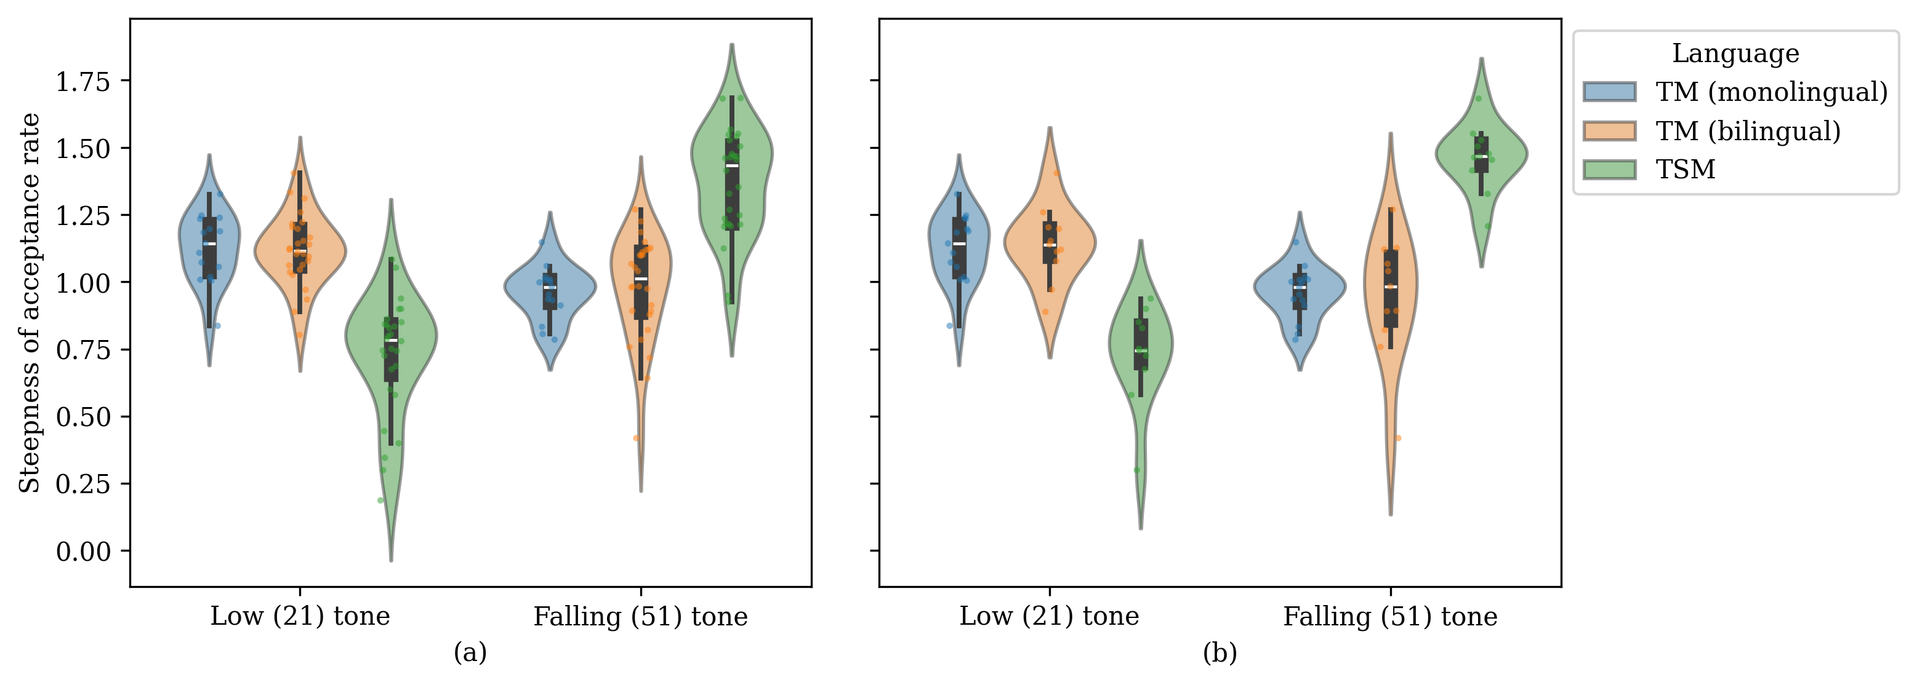
Figure 6. Steepness of acceptance rate for the falling tone and the low tone among the three language groups (all participants: a; advanced speakers only: b).

The regression results are shown in Tables 5 (all speakers) and 6 (advanced speakers only).
Table 5. Regression table for the maximal model examining the steepness of acceptance.
Effect | Est. (±SE) | t-value | p-value
intercept | 1.041±0.032 | 32.734 | <0.001 | ***
language (TM [bilingual]) | 0.007±0.039 | 0.179 | 0.858
language (TSM) | 0.005±0.039 | 0.119 | 0.905
target tone | −0.166±0.064 | −2.604 | 0.010 | *
language (TM [bilingual]):target tone | 0.026±0.079 | 0.329 | 0.742
language (TSM):target tone | 0.809±0.079 | 10.266 | <0.001 | ***
Formula: acceptance slope ∼ language * target tone + (1 | participant)

Table 6. Regression table for the maximal model examining the steepness of acceptance (advanced speakers only).
Effect | Est. (±SE) | t-value | p-value
intercept | 1.041±0.027 | 38.055 | <0.001 | ***
language (TM [bilingual]) | 0.000±0.042 | 0.005 | 0.996
language (TSM) | 0.055±0.042 | 1.296 | 0.199
target tone | −0.166±0.055 | −3.027 | 0.003 | **
language (TM [bilingual]):target tone | −0.029±0.084 | −0.340 | 0.735
language (TSM):target tone | 0.897±0.084 | 10.660 | <0.001 | ***

The regression results show that, contrary to our prediction, the general steepness of acceptance rates was not significantly different between TSM and TM (monolingual; $\hat{β}$=0.005; p=0.905), as well as between TM (monolingual) vs. TM (bilingual; $\hat{β}$=0.007; p=0.858). It should be noted that in this experiment, we take the steepness of the acceptance rates as an indicator of how categorically speakers distinguish between the low tone and the falling tone. As such, this result would serve to suggest that, in general, TSM participants are not more strict/categorical in their perception between the low tone and the falling tone.
However, the regression model also shows an interaction between tone and language (TSM), as also seen in Figure 6, where TSM participants had steeper acceptance rates when the target tone was the falling tone instead of the low tone ($\hat{β}$=0.809; p<0.001). On the flip side, in monolingual TM participants’ perception, it was the low tone that received steeper acceptance rates ($\hat{β}$=−0.166; p=0.01). This difference was not found in bilingual participants’ ($\hat{β}$=0.025; p=0.581) TM perception between the two target tones.
This interaction was even more pronounced when only the advanced bilingual speakers were included in the TSM (bilingual) group ($\hat{β}$=0.897; p<0.001).
Follow-up models were also fitted to examine this cross-language comparison within each of the two target tones. When all participants were included, the steepness of acceptance rates was lower for TSM than TM (monolingual) for the low tone perception ($\hat{β}$=−0.400; p<0.001). On the flip side, it was significantly higher for TSM than TM in the falling tone perception ($\hat{β}$=0.409; p<0.001). When only advanced speakers were considered, such a difference was more salient: TSM had a less steep slope of acceptance than TM for the low tone perception ($\hat{β}$=−0.394; p<0.001), but a steeper slope for the falling tone ($\hat{β}$=0.503; p<0.001). Additionally, it was also found that within the bilingual participants, similar patterns were also attested between TSM and TM for all participants (low tone: $\hat{β}$=−0.394; p<0.001; falling tone: $\hat{β}$=0.389; p<0.001) and advanced participants (low tone: $\hat{β}$=−0.408; p<0.001; falling tone: $\hat{β}$=0.517; p<0.001).
Overall, the results suggested that TSM speakers and TM speakers reacted differently when perceiving low vs. falling tones. When perceiving a low tone, TM speakers had a steeper slope of acceptance rates (more categorical perception). In contrast, when the target was a falling tone, it was the TSM speakers who demonstrated more categorical perception, and this difference was also observed in the bilingual speakers’ responses.

4.2.2 Thresholds of acceptance
The second parameter that was investigated is the threshold of acceptance.
The distribution of the steepness of acceptance rate for the two target tones among the three language groups is shown in Figure 7. The low tone perception seems to pattern with that seen in Figure 6, while the linguistic differences in falling tone perception are less pronounced.
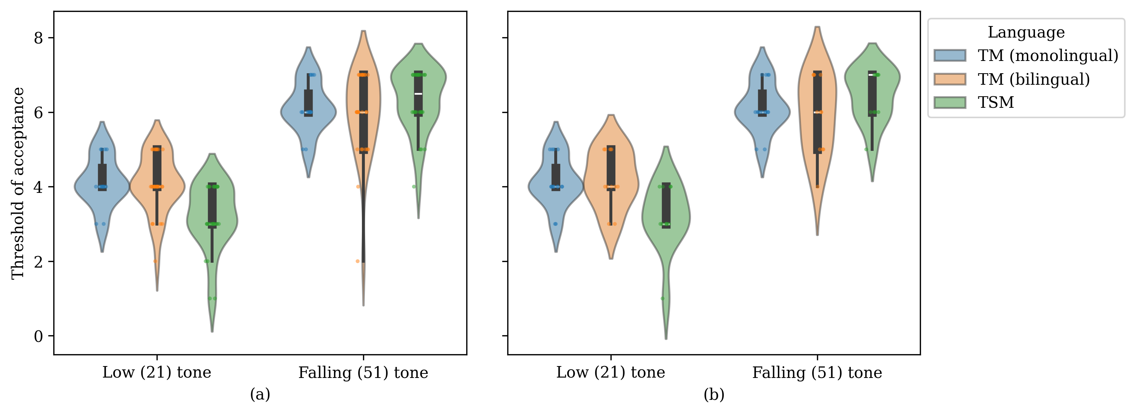
Figure 7. Thresholds of acceptance for the falling tone and the low tone among the three language groups (all participants: a; advanced speakers only: b).

The regression results are shown in Tables 7 (all speakers) and 8 (advanced speakers only).
Table 7. Regression table for the maximal model examining the thresholds of acceptance.
Effect | Est. (±SE) | t-value | p-value
intercept | 5.133±0.165 | 31.039 | <0.001 | ***
language (TM [bilingual]) | −0.133±0.205 | −0.651 | 0.517
language (TSM) | −0.383±0.205 | −1.870 | 0.065
target tone | 2.000±0.298 | 6.707 | <0.001 | ***
language (TM [bilingual]):target tone | −0.143±0.370 | −0.387 | 0.700
language (TSM):target tone | 1.143±0.370 | 3.093 | 0.003 | **
Formula: acceptance threshold ∼ language * target tone + (1 | participant)

Table 8. Regression table for the maximal model examining the thresholds of acceptance (advanced speakers only).
Effect | Est. (±SE) | t-value | p-value
intercept | 5.133±0.154 | 33.237 | <0.001 | ***
language (TM [bilingual]) | −0.088±0.237 | −0.370 | 0.713
language (TSM) | −0.315±0.237 | −1.327 | 0.192
target tone | 2.000±0.245 | 8.171 | <0.001 | ***
language (TM [bilingual]):target tone | −0.273±0.376 | −0.725 | 0.472
language (TSM):target tone | 1.273±0.376 | 3.382 | 0.001 | **
Formula: acceptance threshold ∼ language * target tone + (1 | participant)

Overall, as seen in Figure 7, a very similar pattern was found for the thresholds of acceptance. No systematic differences were found between TSM and TM (monolingual; $\hat{β}$=−0.383; p=0.065). This would suggest that TM participants were not more likely to accept an ambiguous tone as acceptable than their TM counterparts.
Meanwhile, tone-specific differences were once again found. TSM participants had higher thresholds for the falling tone than monolingual TM participants ($\hat{β}$=1.143; p=0.003).
This interaction was also more pronounced when only the advanced speakers were included ($\hat{β}$=1.273; p=0.003).
Examination of follow-up models showed that when all participants were included, the thresholds of acceptance were lower for TSM than TM (monolingual) for the low tone perception ($\hat{β}$=−0.955; p<0.001) but no difference for the falling tone perception ($\hat{β}$=0.188; p=0.532), though the numerical directions patterned similarly (higher thresholds for TSM) as in the maximal model. In addition, when only advanced speakers were considered, such linguistic patterns remained: TSM had less steep slopes of acceptance than TM for the low tone perception ($\hat{β}$=−0.952; p=0.003), but not for the falling tone ($\hat{β}$=0.321; p=0.299).
Overall, we found different acceptance ranges for the low tone and the falling tone in TM and TSM. TSM had a larger acceptance range for the low tone, but a generally stricter acceptance range for the falling tone, though follow-up models showed less robust results. This is likely due to the reduced number of data points for each follow-up model and the subsequent lower power to capture the effects. This is summarized in Table 9.

Table 9. Summary of the results in Experiment 3.
Acceptance measurement | Low tone | Falling tone
Steepness of acceptance rates | TM > TSM | TSM > TM
Threshold of acceptance | TM > TSM | TSM > TM (less robust)

4.3 Discussion
As mentioned previously, it is hypothesized that TSM as a language with a large tone inventory, and the subsequent higher difficulty to recruit perceptual compensation during the processing of coarticulated tones, may maintain narrower tone acceptance ranges to reduce the possibility of confusing a coarticulated tone with another lexical tone. This hypothesis was partially borne out in the results for the falling tone. The results of the steepness and threshold measurements revealed opposite patterns of acceptance range for the low and falling tones in the two languages. It was seen that the acceptance range was narrower in TSM than in TM when participants were asked to judge whether an ambiguous falling tone was a good token, and this trend was more pronounced in the advanced speakers. This trend, however, was not shown when it came to the low tone. This is likely due to the fact that under the sandhi rules in TSM (cf. Appendix D), a low tone is turned into a falling tone. Despite the fact that the stimuli were isolated disyllabic words, and that participants were reminded that the words were produced in isolation with no preceding and following contexts and therefore should not undergo sandhi changes, several reported feeling both the low tone and falling tone to be acceptable for them on the same words, which may be accounted for by the potential sandhi contexts. This might explain why the boundaries for the low tone were not significantly stricter than the falling tone. With this in mind, the results overall suggest that tone acceptance ranges in TSM could be narrower than in TM (though see Section 5.4.4 on the fixed task order). This finding reconciles the question pertaining to the robust tonal coarticulation in both TSM and TM and the weaker perceptual compensation effects seen in TSM as compared with TM. It is inferred that while TSM does not rely as heavily on perceptual compensation when perceiving coarticulated tones, keeping a stricter tone acceptance range may reduce the possible tone confusion induced by tonal coarticulation.

5 General discussion and conclusion

5.1 Production and perception of tonal coarticulation in Taiwan Mandarin and Taiwan Southern Min
This study investigated the production and perception of tonal coarticulation in TM and TSM.
In the three experiments, three aspects were examined: 1) the magnitude of tonal coarticulation, 2) the magnitude of perceptual compensation for tonal coarticulation, and 3) the tone acceptance ranges. It is predicted that TSM, due to a larger tone inventory, may refrain from having the same magnitude of tonal coarticulation as TM and BM to reduce the subsequent tone variations (Hypothesis 1). Alternatively, it is also hypothesized that the magnitude of perceptual compensation for tonal coarticulation may also be lower in TSM due to the lower recoverability of the target tone. Consequently, TSM may opt to maintain stricter tone acceptance ranges to prevent a coarticulated target tone from being perceived as another lexical tone (Hypothesis 2). In our results, the predictions for the second scenario were borne out. For TM, tonal coarticulation was indeed attested, as was observed in BM. Likewise, robust tonal coarticulation was found in both TSM and TM, with TSM showing stronger magnitudes, disfavoring our first hypothesis (Experiment 1). On the flip side, our second hypothesis predicts that a lower recoverability for TSM would increase the difficulty of TSM to rely entirely on perceptual compensation, and TSM would, in turn, require other perceptual mechanisms. Indeed, while both TM and TSM listeners employed perceptual compensation to compensate for tonal coarticulation, the perceptual compensation observed in TSM was significantly weaker than in TM (Experiment 2). Conversely, TSM also demonstrated narrower ranges of tone acceptance (at least for the falling tone), serving as an auxiliary mechanism in response to tone variations induced by tonal coarticulation (Experiment 3).
Our results therefore suggest that the realization of tonal coarticulation is not obviously constrained by language-specific structural factors. Speakers instead cope with the structural differences across languages through perceptual mechanisms. This result is therefore compatible with the account that tonal coarticulation is universal, driven by phonetic constraints. This conception, however, requires further scrutiny and shall be discussed in the next section.
Our study also points out the two proposed perceptual mechanisms, i.e., perceptual compensation and tone acceptance range, as two potentially independent and interacting factors that jointly modulate the perception of tonal coarticulation cross-linguistically. Such a possibility remains to be tested in further sresearch.

5.2 Universality of tonal coarticulation
As mentioned in Section 1.1, there is still a debate on whether tonal coarticulation is a universal constraint induced by biomechanical factors (e.g., Shen 1992), or is conditioned by phonological contrasts and may thus vary among languages (e.g., Brunelle 2009; Flemming 2011). One objective of this study is to investigate whether differences in tone inventory sizes would lead to correspondingly different magnitudes of tonal coarticulation, as has been found in segmental coarticulation (Manuel 1990). TSM, with its larger tone inventory, is expected to exhibit more constrained tonal coarticulation, as it faces greater pressure to avoid perceptual confusion among tones. This was, however, not the case in the results. Instead, tonal coarticulation was stronger in terms of magnitude in TSM than in TM.
We should, however, not rush to conclude that tonal coarticulation is conditioned purely by biomechanical constraints. Firstly, we do see that tonal coarticulation differs between TM monolingual speakers’ production and bilingual speakers’ TSM production, and also within the bilingual speakers when they produce TM versus TSM, though in a direction opposite to our prediction. Secondly, while an inverse result (differences in magnitudes in the predicted direction attested) would serve as solid evidence that tonal coarticulation is unlikely to be constrained merely by biomechanical factors, as linguistic factors are found, the reverse does not hold. One counterpoint would be the one proposed in Flemming (2011), where coarticulation is argued to be integrated into phonological grammar, with different prioritizations of articulatory and perceptual ease. Flemming argues that linguistic differences in coarticulation, such as tonal coarticulation and fronting effects of back vowels, serve as evidence that coarticulation is entrenched in phonology, with language-specific preferences of whether to prioritize articulatory or perceptual ease first.
Under this account, while a null effect of differences in inventory sizes in the predicted direction is potentially compatible with a purely phonetic view of tonal coarticulation, it also cannot rule out the possibility of the phonological account. Such a result may well come from different prioritizations in both TM and TSM that cannot be accounted for by tone inventory size. Specifically, while robust tonal coarticulation was found in both TSM and TM, differences in directionality were attested between BM and TM/TSM. In the current study, a more symmetric distribution was found for both TM and TSM. The general patterns for both carryover effects and anticipatory effects were assimilatory in both languages, despite certain inconsistencies. While such distributions are rather consistent with the TM results in Jeng (2012) and Huang (2013), and the TSM results in Peng (1997) and Wang (2002), such distributions are different from the findings of most previous studies in BM, where asymmetric distributions were consistently found (cf. Chang and Hsieh 2012), with carryover effects being assimilatory and anticipatory effects being dissimilatory. Such discrepancies, once again, support the view that tonal coarticulation may not be entirely insensitive to phonological and linguistic factors. Crucially, we attribute such an anomaly in TSM to the final prominence, as proposed in Chang and Hsieh (2012). A similar distribution in TM may in turn stem from language contact with TSM.
In general, while the magnitudes of tonal coarticulation in the two languages do not support a language-specific account, distributional differences in directionality do suggest that tonal coarticulation is in part subject to language-specific factors.

5.3 Tonal coarticulation and tonal dispersion
Lastly, another issue that is tightly related to the articulatory and perceptual mechanisms under coarticulation attested in this study is tonal dispersion. As briefly mentioned in Section 1.3, Dispersion Theory (Lindblom 1986, and 1990) states that speech communication is mediated by the tug-of-war between articulatory ease and perceptual contrast. Previous studies examining tone systems further extended the application of this theory from vowel systems to tonal dispersion (e.g., Alexander 2010; Kuang 2013). In Alexander (2010), for instance, it was found that while the overall pitch ranges across languages with varying tone inventory sizes were comparable, sufficient contrast/dispersion was made for tonal distinction in the 2D onset-offset space. Likewise, Kuang (2013) also noted that in Black Miao, the additional use of phonation on top of pitch helps maintain the tonal dispersion among the multiple level tones.
The perceptual findings in this study, therefore, further inform us about the nature of tonal dispersion and the tug-of-war between articulatory ease and perceptual contrast. While these previous studies mainly focus on the role that the speaker plays in speech communication, the perceptual findings found in Experiment 3 suggest that the listener may also take on a more active role in speech communication. In this study, it was found that listeners may not always passively rely on speakers’ efforts to make larger contrasts. Listeners may also actively adjust their own perceptual acceptance to filter out confusable targets.

5.4 Limitations

5.4.1 Other possible mechanisms
Compared with a large number of studies on tonal coarticulation, much less work has investigated the perception of coarticulated tones. Most previous studies (e.g., Xu 1997; Zhang et al. 2022) merely focused on the role of perceptual compensation for tonal coarticulation as a possible mechanism to cope with the induced tone variations. In this study, we propose an alternative perceptual mechanism at work: tone acceptance ranges. Our results revealed that different ranges of tone acceptance between languages may help reduce the possibility of perceptual confusion induced by tone variations.
It should be noted, however, that while this study focused only on three aspects regarding the routes from production to perception under tonal coarticulation, it should not be ignored that other mechanisms could also help differentiate one tone from another. Specifically, the present study principally considered pitch as a factor that could influence the production and perception of tones. Nevertheless, several previous studies have found that factors other than pitch may also modulate the production and perception of tones. One important factor put aside was lexicality. Studies have found that lexicality could promote the perception of tones. For example, children’s perception of Cantonese lexical tones was found to be better for words than non-words (Lee et al. 2002). Similarly, acoustic cues other than pitch were also shown to help differentiate lexical tones. Durational differences have been found to influence the perception of Mandarin rising tones and low tones (Blicher et al. 1990). Likewise, Kuang (2013) has found that phonation types could also be an additional dimension that helps to promote the distinction of lexical tones. Huang (2025) further found that creaky voicing is dissociable from the F0 contours in tonal coarticulation; this also suggests that voicing qualities could serve as an acoustic correlate for tone perception. Overall, whether other acoustic cues or phonation types interplay with tonal coarticulation would call for future research.

5.4.2 The facilitatory effects of tonal coarticulation in lexical identification
In this study, we discuss the effect of tonal coarticulation as potentially hindering tone identification due to the potential of confusing different lexical tones. Several studies, however, have also shown that in contexts where the tones are not confusable (e.g., the two tones do not construct a minimal lexical pair), tonal coarticulation could serve as useful acoustic cues in lexical identification. Li (2023), for example, examined lexical identification with the Visual World Paradigm, and found that the Tianjin Mandarin speakers could identify the target word from a competitor that shared the same initial syllable faster when the second tone raised the pitch of the first tone in the target word. Such a finding was further replicated in Hasanah et al. (2024) on BM speakers. Likewise, Qin and Zhang (2024) also showed from eye-tracking data that tonal coarticulation helped the Cantonese-speaking participants identify the target word from a tonally mismatched competitor.
These results, therefore, suggest that tonal coarticulation may not always be dispreferred in speech perception, and that our findings need to be understood in a more contextually specific way.

5.4.3 Limited stimuli: other lexical tone pairs, the anticipatory effects, and model speakers
Another limitation of this study is the limited tone pairs and lexical items examined. In this study, only the low/falling tones in the carryover position were investigated. It is possible that the perceptual mechanisms of lexical tones under tonal coarticulation may differ for different tone pairs. Specifically, it is argued that the unexpected results in Experiment 3 may be due to tone sandhi between the low tone and the falling tone in TSM. The rising vs. high-level tone pair may, in this case, be ideal: In both languages, one does not become the other tone under tone sandhi, and they only differ in their onsets.
On the flip side, we might expect similar trends on other tone pairs for the perceptual compensation results in Experiment 2. While both this study and Zhang et al. (2022) only examined the low-falling tone continuum, Zhang et al. also inspected the perceptual compensation on non-linguistic pure tones, where similar, though weaker, effects were found. This suggests that perceptual compensation could be a general cognitive mechanism that is further tuned by linguistic experiences. We might thus expect to find perceptual compensation in other tone pairs or in the opposite (anticipatory) direction, and a similar language-specific difference.
Item-specific lexical variability may also affect how tonal coarticulation is realized in production and perceived by the language users. In this study, we accounted for such variability through the inclusion of segment-level effects and word frequency effects. However, since each tone combination in Experiments 1 and 2 was realized only by one lexical item, the generalizability of our results is constrained. We therefore recognize that the coarticulation results cannot be readily generalized across all lexical items, nor does the perceptual compensation in Experiment 2 apply automatically across the board.
Lastly, in Experiments 2 and 3, the model speaker identity also confounded language. The intrinsic inter-speaker voice difference could also have contributed to the language differences attested.
Overall, however, further investigation is required for a more comprehensive conclusion to be drawn.

5.4.4 Experiment order
We would also like to address the limitation that in all three experiments where the participants participated in both languages, the TM experiment always preceded the TSM one. We fixed this order instead of randomizing because all of our TSM speakers predominantly use TM in daily life. The participants were therefore all less familiar with the stimuli in TSM. To avoid the participants’ potential confusion about what tasks to do, we decided to always start with the language they were more familiar with.
This is a limitation due to the linguistic reality in Taiwan, but we would like to state that this order could confound the cross-linguistic differences we see in the three experiments. Specifically, two potential confounds are the fatigue effects and the participant’s increased familiarity with the task when doing the TSM experiments. On the one hand, the fatigue effects could reduce participants’ attention to the task, leading to the lower compensation attested in Experiment 2. Though we would also like to note that Experiments 2 and 3 were relatively short, with most participants finishing the two experiments for both languages (4 blocks) in less than an hour, with each block lasting about 10 minutes and breaks in between. The fatigue effects, if any, would thus be stronger between Experiments 2 and 3 than between the two languages. On the other hand, the increased familiarity could also allow the participants to be more sensitive to the stimuli’s differences across levels in Experiments 2 and 3.

5.4.5 Participants’ variability in Taiwan Southern Min fluency
Lastly, another factor to address is the variable levels of fluency of the participants in TSM. As also mentioned above, the linguistic landscape in Taiwan is that most younger TSM speakers are predominantly TM speakers. This resulted in the varying levels of TSM fluency among our participants. While we restricted the production experiment to only advanced (self-reported fluency score of eight or higher) speakers, our perception experiment results included all participants. As found in Experiment 3 in Section 4.2, there exists perceptual differences between advanced speakers and intermediate speakers. We therefore also examined the effects of fluency on the compensation and tone acceptance in Experiments 2 and 3. In Experiment 2, no fluency effects were found to interact with compensation. In Experiment 3, however, as the TSM fluency increased, the acceptance slopes became steeper for the target tone and less steep for the low tone. This suggests that the language differences between TSM and TM were more pronounced in more advanced speakers.
Overall, however, it is still possible that the linguistic (non-)differences attested in this study are the result of our TSM speakers converging toward TM, advanced and intermediate speakers alike. All of our TSM speakers are dominant in TM and acquired TSM with comparatively constrained input. This is comparable to the acquisition of heritage languages, and their TSM may consequently carry the influence coming from TM. This is also consistent with the more pronounced linguistic differences seen in advanced speakers. It is therefore possible that further linguistic differences could be found in predominantly monolingual speakers of TSM. Such speakers, however, would be hard to recruit given the linguistic landscape in Taiwan.

6 Conclusion
This study investigated the routes from production to perception under tonal coarticulation in Taiwan Mandarin and Taiwan Southern Min. The results revealed that Taiwan Southern Min did not show reduced tonal coarticulation relative to Taiwan Mandarin; instead, TSM showed stronger tonal coarticulation in the present analysis. The two languages, however, differed in their perceptual mechanisms. In Taiwan Mandarin, stronger perceptual compensation for tonal coarticulation was found, as in Beijing Mandarin. On the flip side, Taiwan Southern Min was found to have weaker perceptual compensation and tone-specific tone acceptance ranges, with a narrower range for the falling tone but a wider range for the low tone.
This study is the first to investigate the issue of both tonal coarticulation and related perception in Taiwan Mandarin and to make a systematic comparison with Taiwan Southern Min. Specifically, this study discusses a novel perceptual mechanism, that is, tone acceptance ranges, which has been overlooked in previous studies. The authors hope that this study may shed light on the different mechanisms of the production and perception of coarticulated tones, and also provide further clues for the issue of linguistic universals and specificities.

Acknowledgment
This work was supported by the National Science and Technology Council, Taipei City, Taiwan. (NSTC 110-2410-H-002-032).
Ethics Statement
The experimental procedures in this project have been approved by the Institutional Review Board of the Office of Research and Development, National Taiwan University, Taipei, Taiwan (project name: The relationship between tongue postures and tongue centers: Analyses and computer-assisted applications). All the participants have signed the consent forms approved by the said Board, detailing their rights, the data to be collected, and the experimental procedures.
Author Contributions
First author: Conceptualization, Methodology, Software, Formal analysis, Investigation, Data Curation, Writing - Original Draft, Writing - Review & Editing, Visualization, Supervision, Project administration
Second author (corresponding): Methodology, Validation, Resources, Writing - Original Draft, Writing - Review & Editing, Supervision, Project administration, Funding acquisition
Conflict of Interest
The authors have no conflicts to disclose.
Data Availability
The data and codes used in this project have been made openly accessible. See this Open Science Framework repository for the experimental designs, collected data, codes, and results: https://osf.io/zcu5m/?view_only=db0d37ea2cc74bf7b9a4de5532238e70

Appendix A: Experiment 1
1. Prompts for fluency score elicitation
「從1到10，你覺得你的台語有多流利？1代表完全不會說；10代表母語程度。」‘On a scale from 1 to 10, how fluent do you think your Taiwanese is? One means that you cannot speak it at all; ten means it is native-like.’
2. Stimuli
Table 10: Taiwan Mandarin version.
Second tone
First tone | T1 (55) | T2 (35) | T3 (21) | T4 (51)
T1 (55) | 邀約 /jɑʊ.ɥe/  ‘invitation’  T1 (55)+T1(55) | 幽靈 /joʊ.liŋ/  ‘ghost’  T1 (55)+T2 (35) | 邀舞 /jɑʊ.u/  ‘invitation to dance’  T1 (55)+T3 (21) | 衣物 /i.u/  ‘clothes’  T1 (55)+T4 (51)
T2 (35) | 牙醫 /ja.i/  ‘dentist’  T2 (35)+T1 (55) | 魷魚 /joʊ.y/  ‘squid’  T2 (35)+T2 (35) | 游泳 /joʊ.joŋ/  ‘to swim’  T2 (35)+T3 (21) | 猶豫 /joʊ.y/  ‘to hesitate’  T2 (35)+T4 (51)
T3 (21) | 女巫 /ny.u/  ‘witch’  T3 (21)+T1 (55) | 有餘 /joʊ.y/  ‘to have something left’  T3 (21)+T2 (35) |  | 網路 /wɑŋ.lu/  ‘Internet’  T3 (21)+T4 (51)
T4 (51) | 夜鶯 /je.iŋ/  ‘nightingale’  T4 (51)+T1 (55) | 誤移 /u.i/  ‘to move by mistake’  T4 (51)+T2 (35) | 誘餌 /joʊ.ə/  ‘bait’  T4 (51)+T3 (21) | 藥物/jɑʊ.u/  ‘medication’  T4 (51)+T4 (51)

Table 11: Taiwan Southern Min version.
 | Second tone
First tone | T1 (55) | T2 (51) | T3 (21) | T5 (35) | T7 (33)
T1 (55) | 烏貓 /ɔ.njɑʊ/  ‘black cat’  T1’ (33)+T1(55) | 阿母 /a.bu/  ‘mother’  T1’ (33)+T2 (51) | 哀怨 /aj.wan/  ‘grief’  T1’ (33)+T3 (21) | 阿娘 /a.nja/  ‘mother’  T1’ (33)+T5 (35) | 因為 /in.uj/  ‘because’  T1’ (33)+T7 (33)
T2 (51) | 按呢 /an.ne/  ‘like this’  T2’ (55)+T1 (55) | 母語 /bu.gi/  ‘mother tongue’  T2’ (55)+T2 (51) | 滿意 /mwa.i/  ‘satisfied’  T2’ (55)+ T3 (21) | 理由 /li.ju/  ‘reason’  T2’ (55)+ T5 (35) | 美麗 /bi.le/  ‘beauty’  T2’ (55)+T7 (33)
T3 (21) | 暗安 /am.an/  ‘good night’  T3’ (51)+T1 (55) | 懊惱 /ɑʊ.nɑʊ/  ‘to regret’  T3’ (51)+T2 (51) | 落落 /lɑʊ.lɑʊ/  ‘loose’  T3’ (51)+ T3 (21) | 愛人 /aj.lin/  ‘lover’  T3’ (51)+ T5 (35) | 向望 /ŋ.baŋ/  ‘hope’  T3’ (51)+T7 (33)
T5 (35) | 牛奶 /gu.liŋ/  ‘milk’  T5’ (33/21)+T1 (55) | 麻-lau /mwa.lɑʊ/  ‘a kind of dessert’  T5’ (33/21)+T2 (51) | 無愛 /bo.aj/  ‘dislike’  T5’ (33/21)+ T3 (21) | 明年 /me.ni/  ‘next year’  T5’ (33/21)+ T5 (35) | 眠夢 /bin.baŋ/  ‘dream’  T5’ (33/21)+T7 (33)
T7 (33) | 內奶 /lai.liŋ/  ‘inner tire’  T7’ (21)+T1 (55) | 袂-bai /bwe.baj/  ‘not bad’  T7’ (21)+T2 (51) | 議案 /gi.an/  ‘motion’  T7’ (21)+ T3 (21) | 未來 /bi.laj/  ‘future’  T7’ (21)+ T5 (35) | 下面 /e.bin/  ‘below’  T7’ (21)+T7 (33)

3. Tone contour visualization (through GAMM)
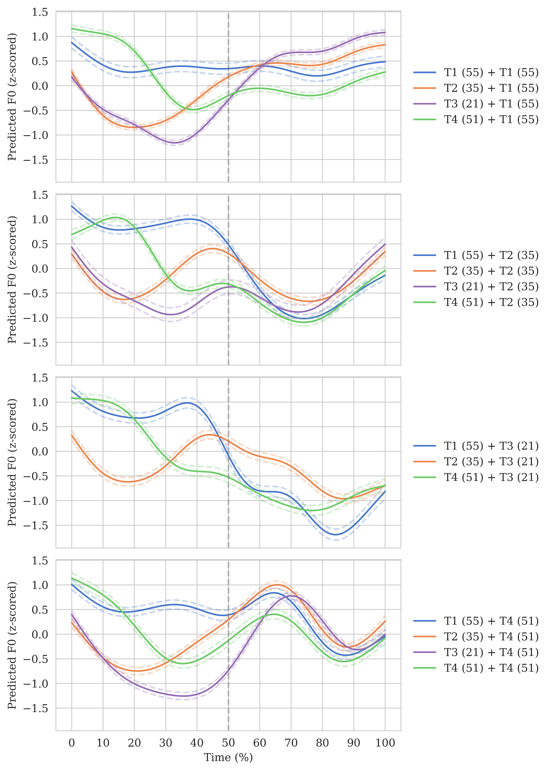
Figure 8. Taiwan Mandarin tone contours (produced by monolingual speakers) under carryover effects. The dashed line indicates the syllable boundary.
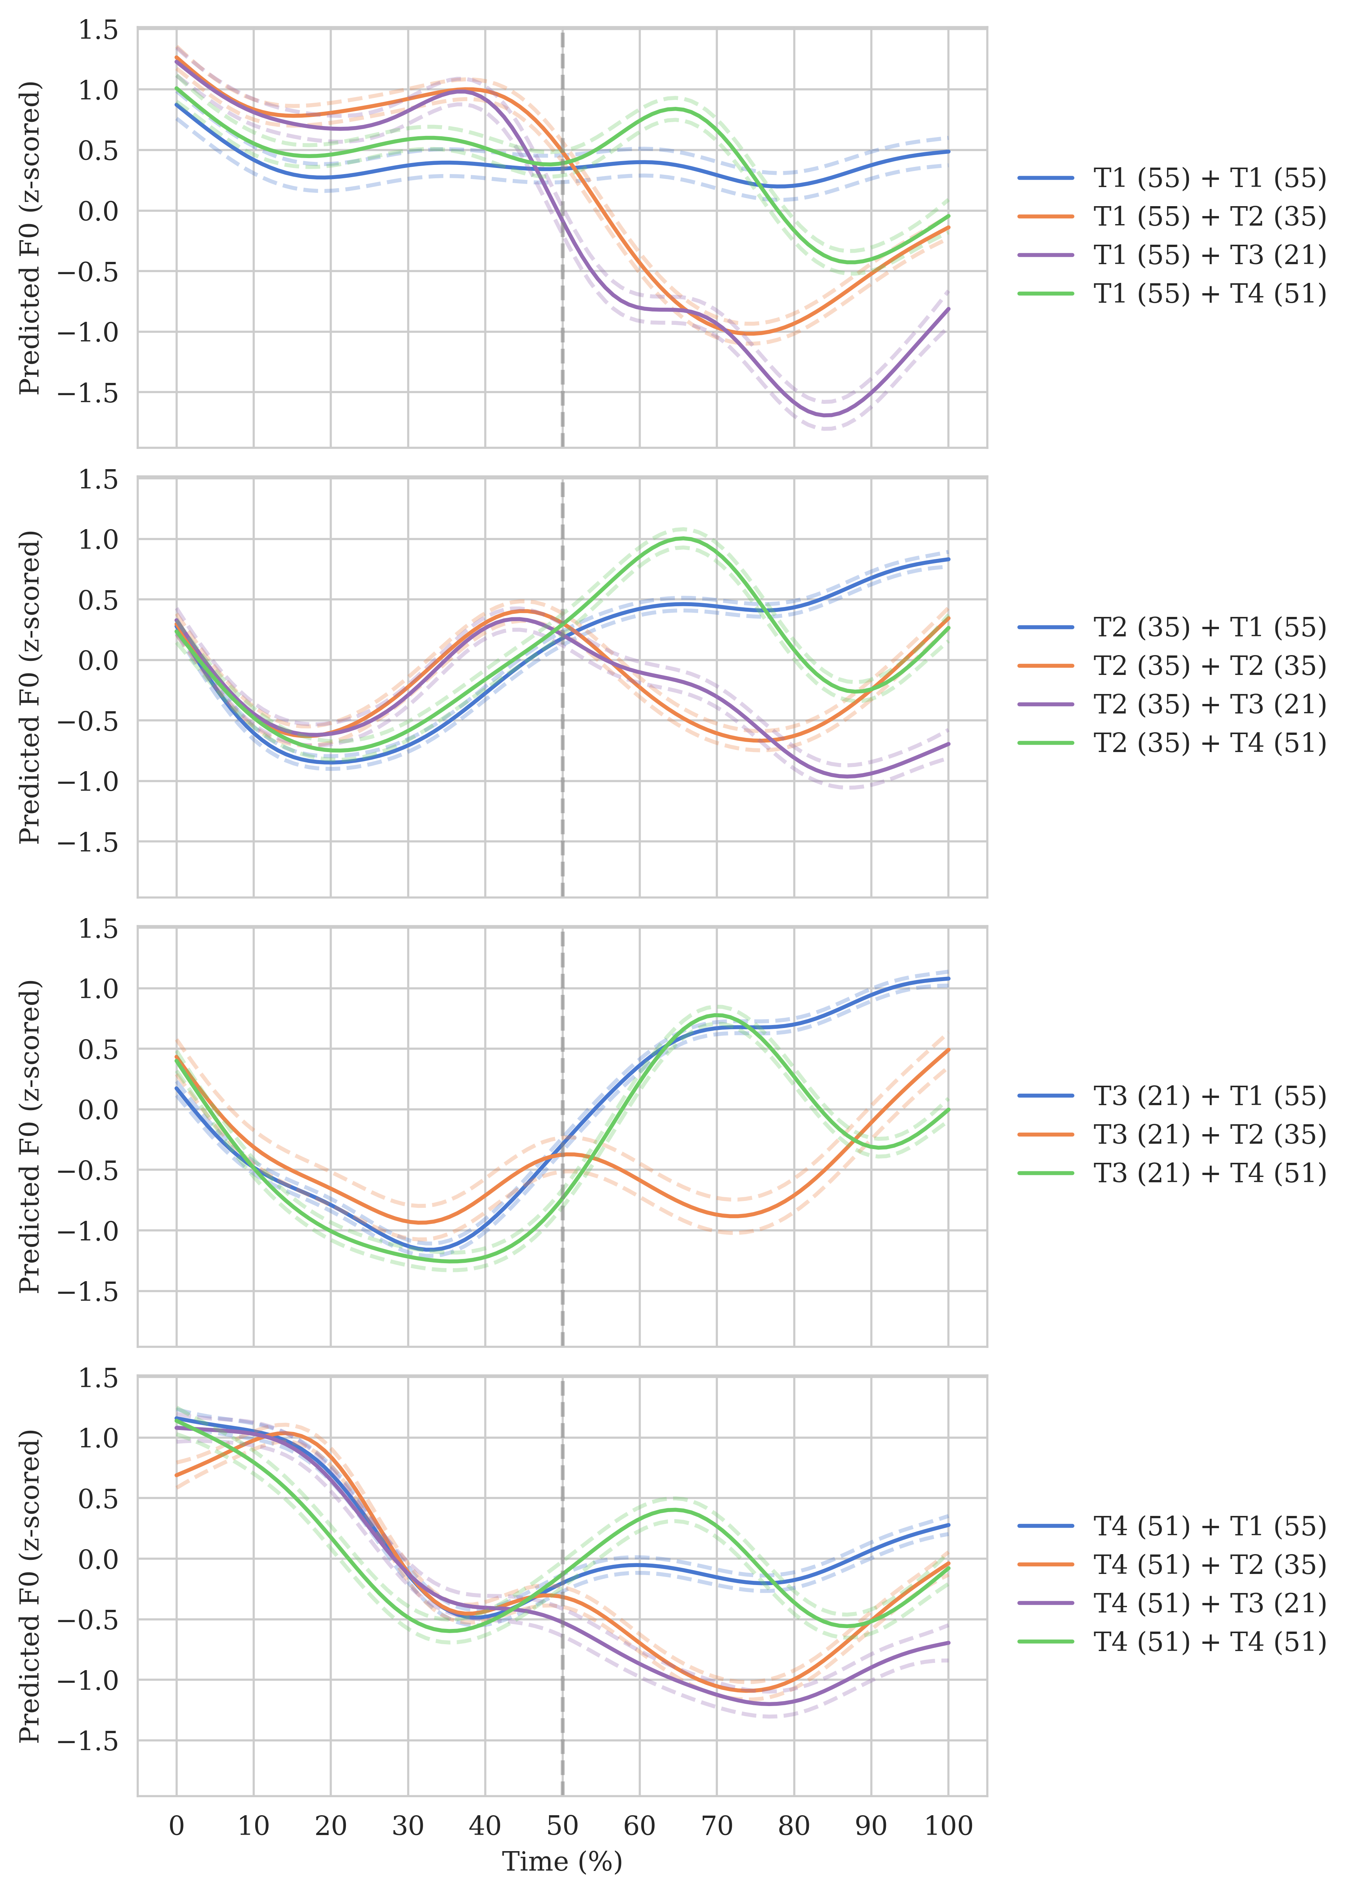
Figure 9. Taiwan Mandarin tone contours (produced by monolingual speakers) under anticipatory effects. The dashed line indicates the syllable boundary.
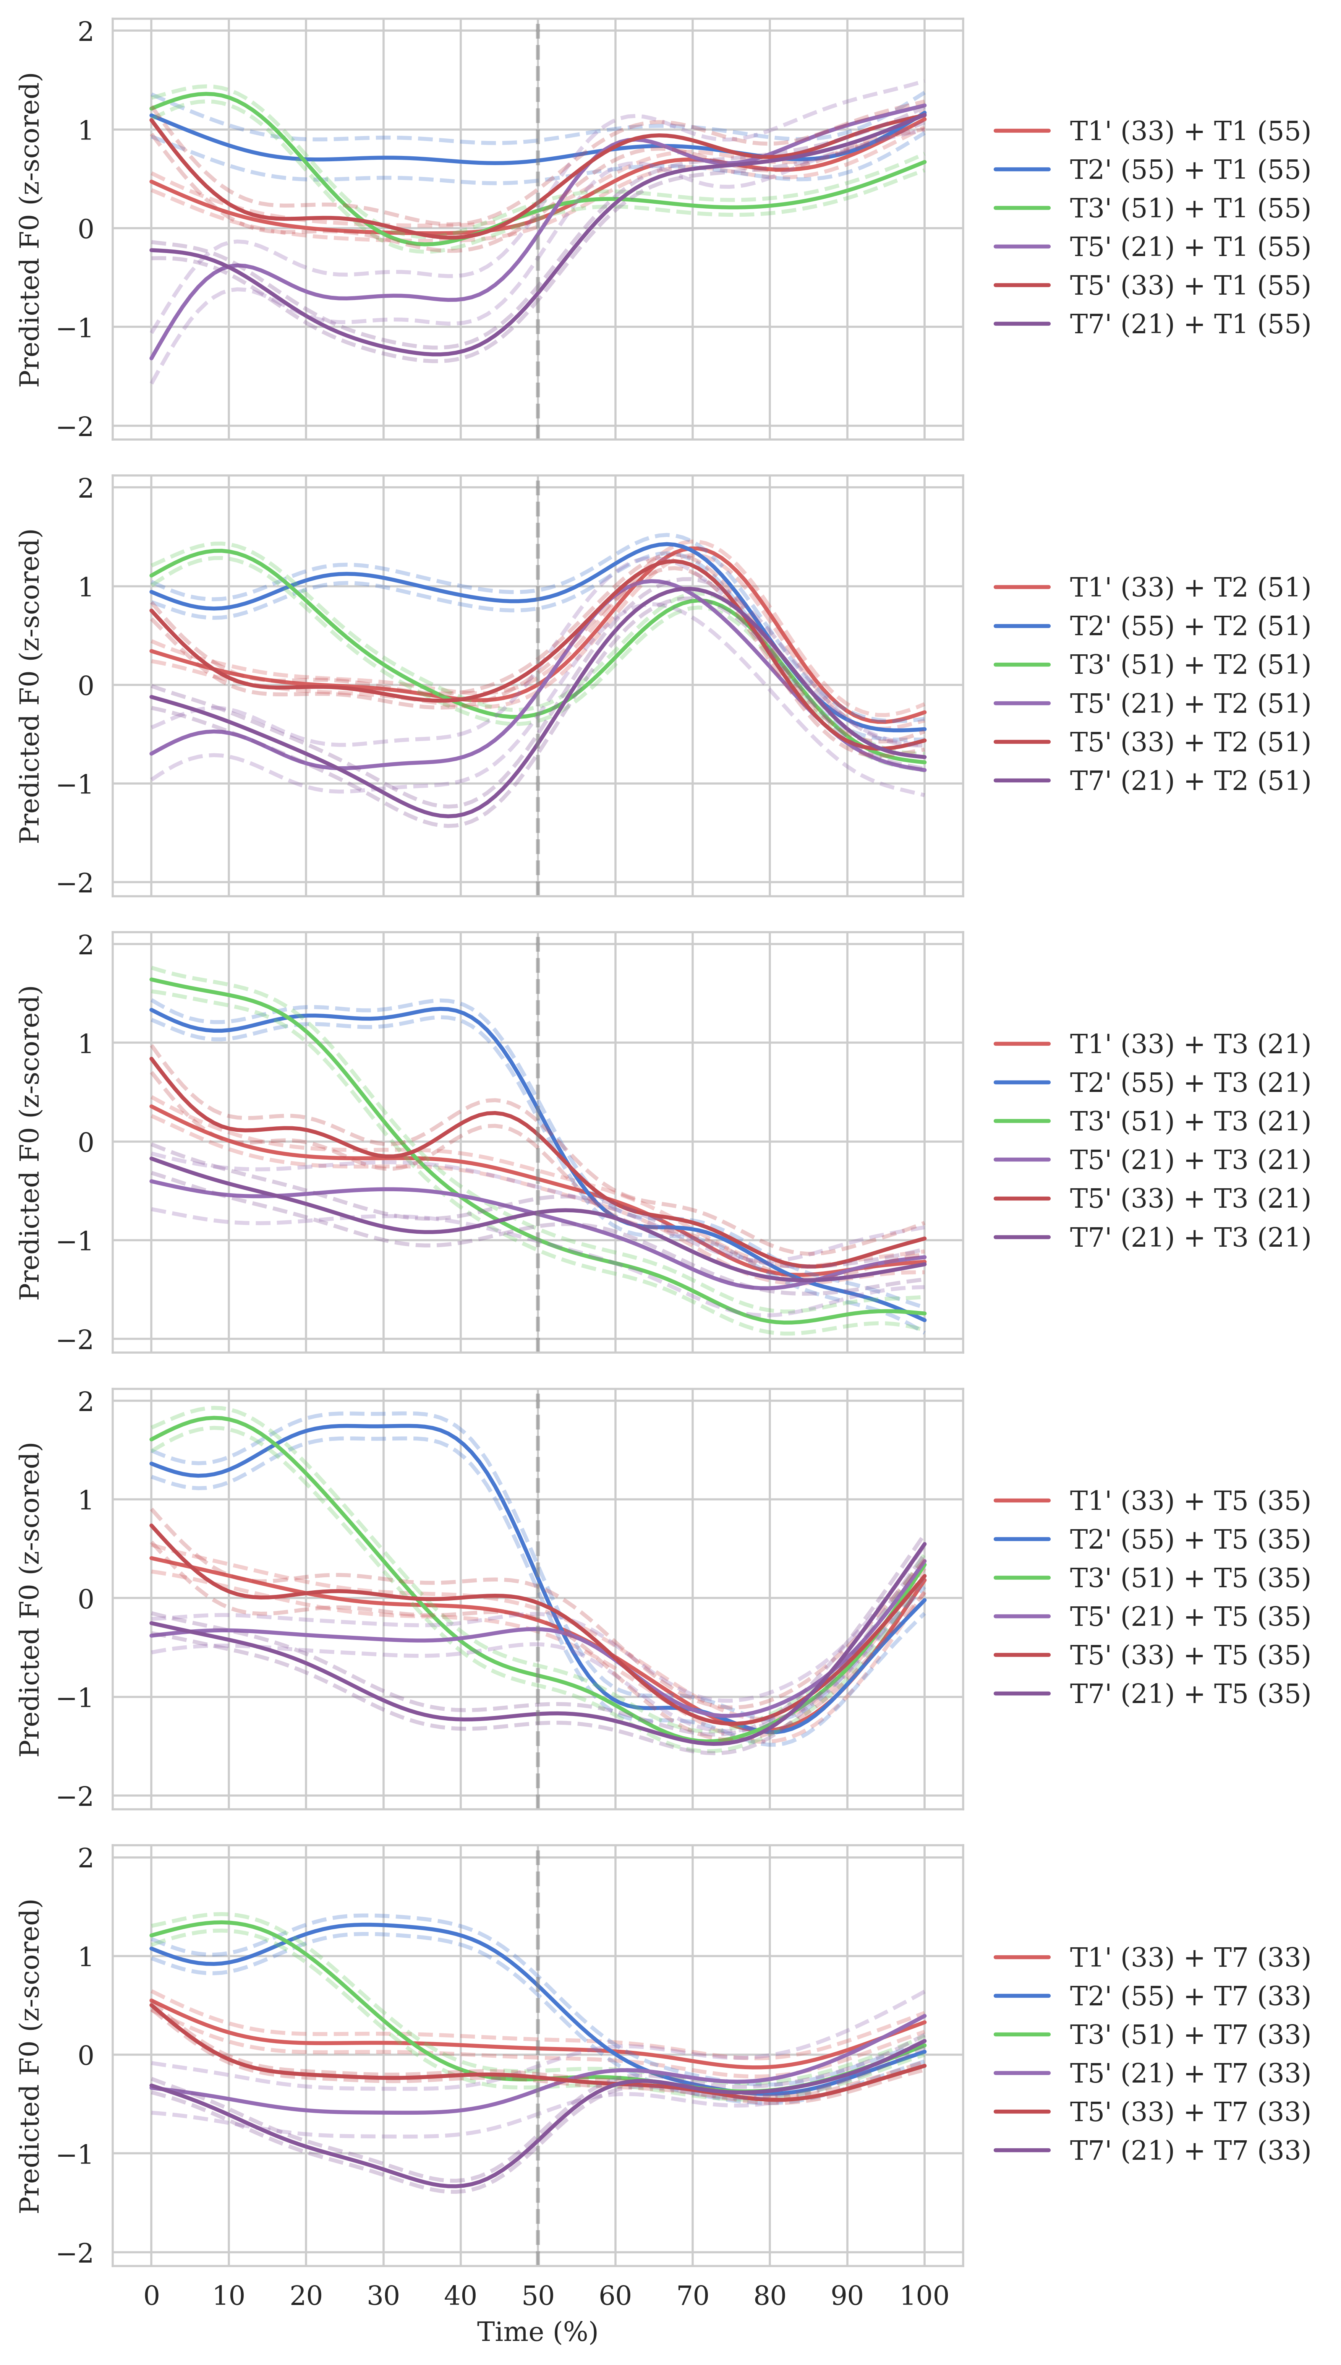
Figure 10. Taiwan Southern Min tone contours under carryover effects. The dashed line indicates the syllable boundary.
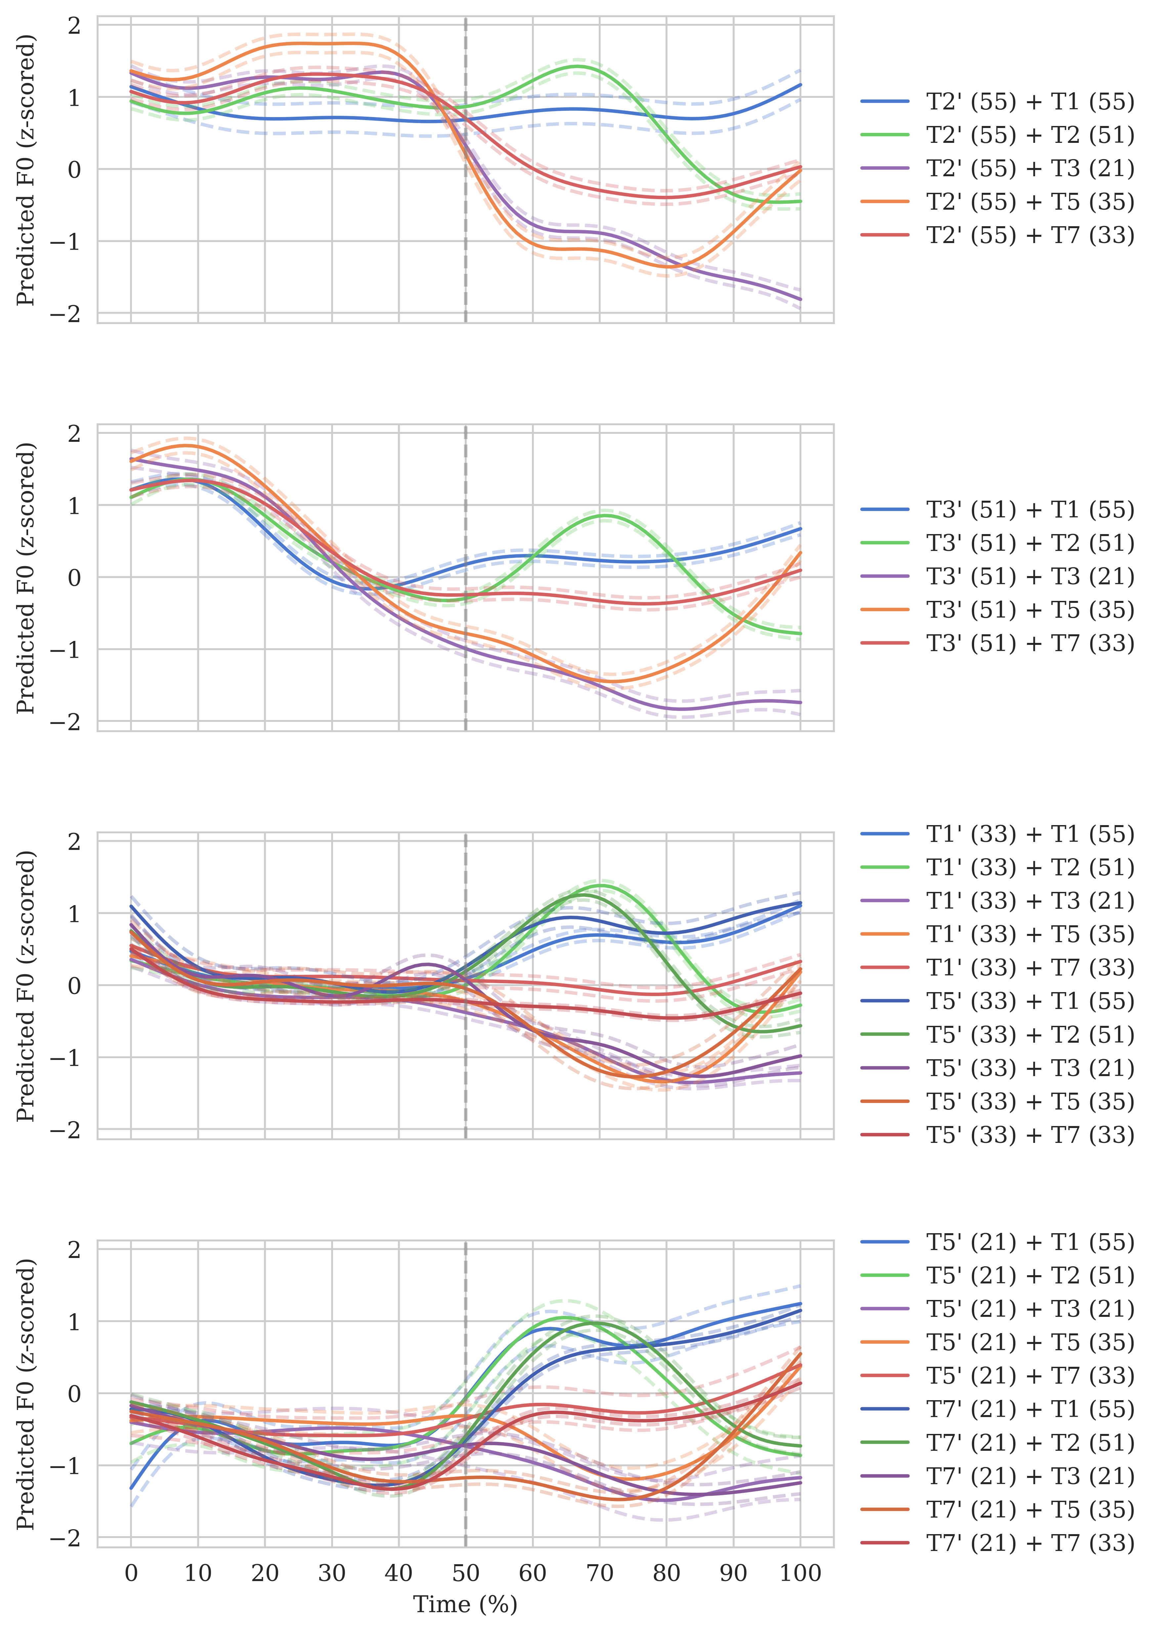
Figure 11. Taiwan Southern Min tone contours under anticipatory effects. The dashed line indicates the syllable boundary.

4. Linear mixed-effects model visualization
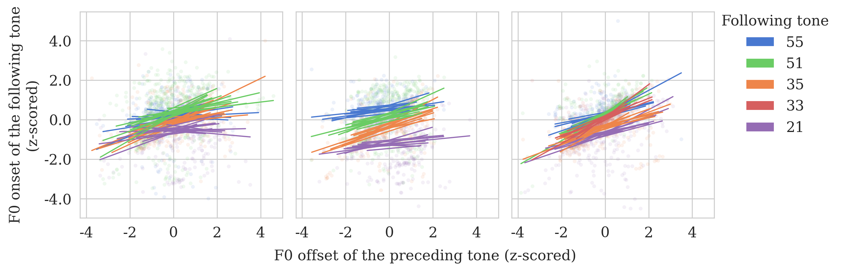
- Carryover effects.
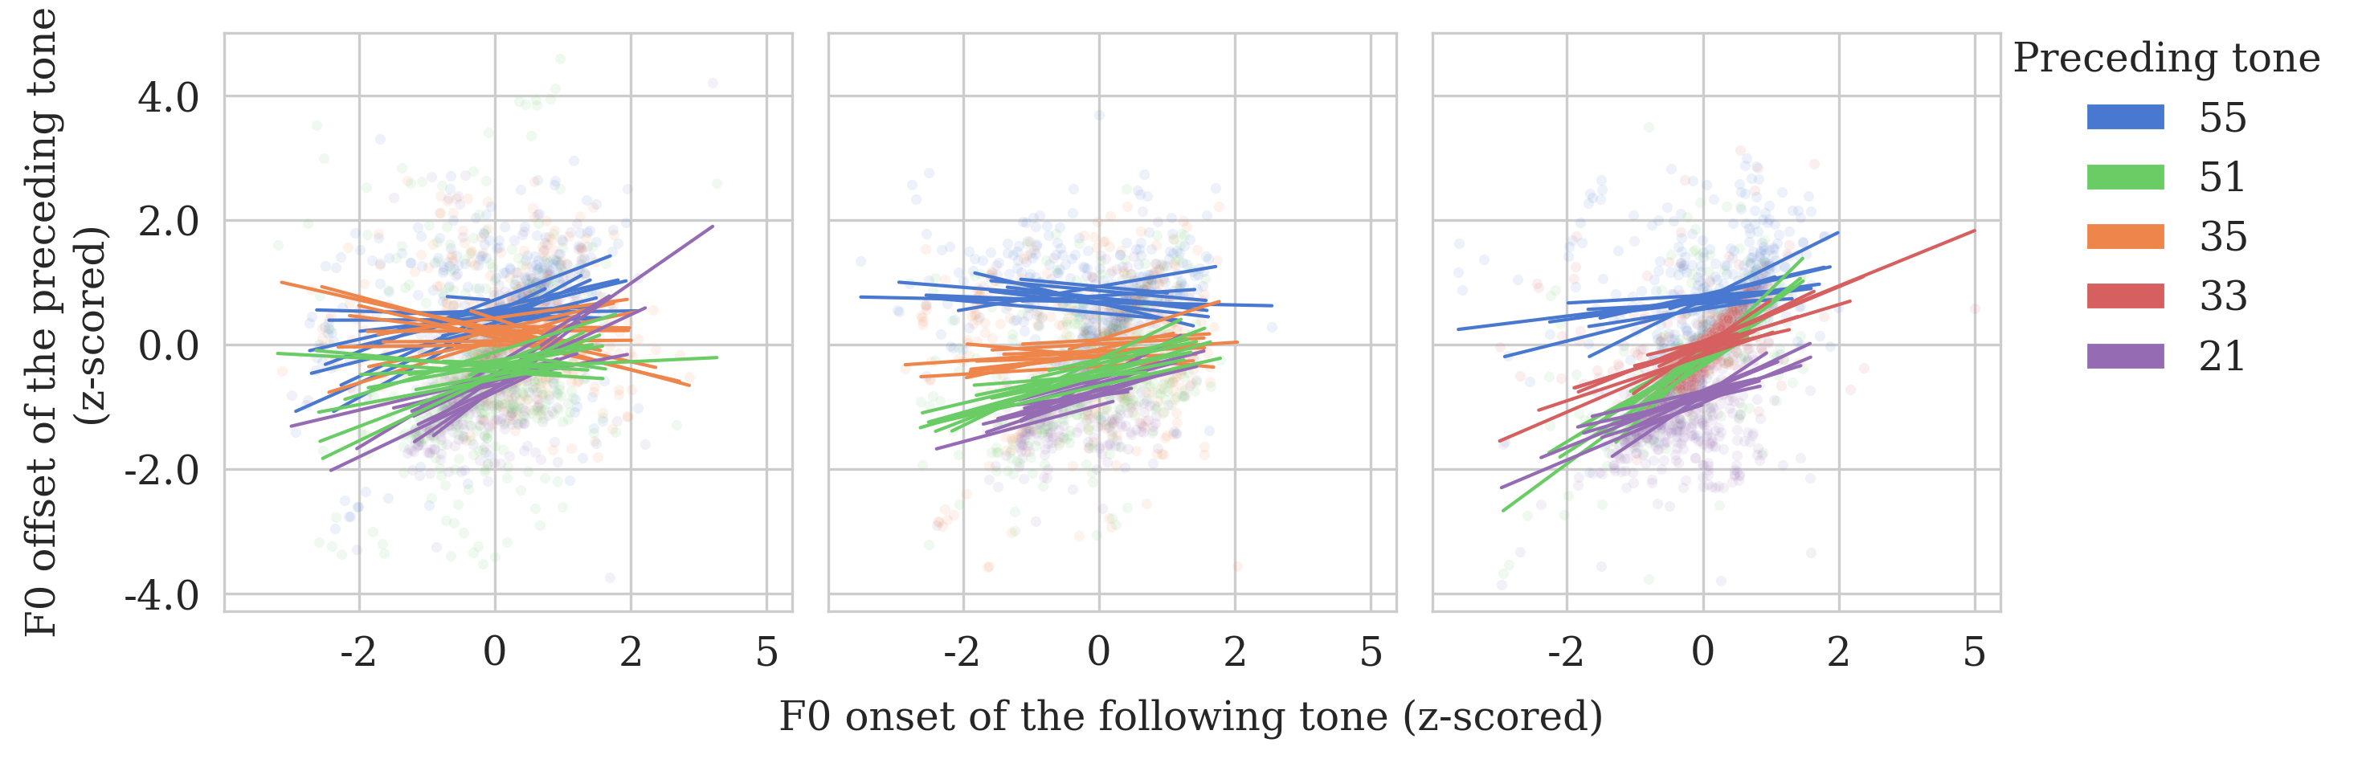
- Anticipatory effects.
Figure 12. Linear mixed-effects model visualization.
5. Individual tone comparisons
Table 12. Post-hoc pairwise comparisons of the effects of context tone values on target tone values between different target tones.
Language group | Position | Comparison | Est. (±SE) | t-ratio | p-value
TSM (advanced) | Carryover | low (21)>mid-level (33) | 0.123±0.065 | 1.875 | 0.332
TSM (advanced) | Carryover | low (21)>rising (35) | 0.171±0.036 | 4.715 | <0.001 | ***
TSM (advanced) | Carryover | low (21)>falling (51) | 0.100±0.059 | 1.687 | 0.442
TSM (advanced) | Carryover | low (21)>high-level (55) | 0.288±0.060 | 4.815 | <0.001 | ***
TSM (advanced) | Carryover | mid-level (33)>rising (35) | 0.048±0.067 | 0.726 | 0.950
TSM (advanced) | Carryover | falling (51)>mid-level (33) | 0.023±0.060 | 0.381 | 0.996
TSM (advanced) | Carryover | mid-level (33)>high-level (55) | 0.165±0.065 | 2.561 | 0.079
TSM (advanced) | Carryover | falling (51)>rising (35) | 0.071±0.056 | 1.268 | 0.711
TSM (advanced) | Carryover | rising (35)>high-level (55) | 0.117±0.062 | 1.887 | 0.362
TSM (advanced) | Carryover | falling (51)>high-level (55) | 0.188±0.077 | 2.439 | 0.122
TSM (advanced) | Anticipatory | mid-level (33)>low (21) | 0.128±0.047 | 2.749 | 0.032 | *
TSM (advanced) | Anticipatory | falling (51)>low (21) | 0.145±0.046 | 3.144 | 0.009 | **
TSM (advanced) | Anticipatory | low (21)>high-level (55) | 0.027±0.044 | 0.612 | 0.928
TSM (advanced) | Anticipatory | falling (51)>mid-level (33) | 0.017±0.053 | 0.308 | 0.990
TSM (advanced) | Anticipatory | mid-level (33)>high-level (55) | 0.155±0.043 | 3.656 | 0.002 | **
TSM (advanced) | Anticipatory | falling (51)>high-level (55) | 0.172±0.055 | 3.124 | 0.013 | *
TM (monolingual) | Carryover | low (21)>rising (35) | 0.055±0.078 | 0.709 | 0.893
TM (monolingual) | Carryover | falling (51)>low (21) | 0.250±0.082 | 3.041 | 0.039 | *
TM (monolingual) | Carryover | high-level (55)>low (21) | 0.071±0.113 | 0.630 | 0.919
TM (monolingual) | Carryover | falling (51)>rising (35) | 0.305±0.064 | 4.801 | <0.001 | ***
TM (monolingual) | Carryover | high-level (55)>rising (35) | 0.127±0.082 | 1.553 | 0.413
TM (monolingual) | Carryover | falling (51)>high-level (55) | 0.179±0.066 | 2.692 | 0.037 | *
TM (monolingual) | Anticipatory | low (21)>rising (35) | 0.312±0.089 | 3.506 | 0.003 | **
TM (monolingual) | Anticipatory | low (21)>falling (51) | 0.130±0.104 | 1.252 | 0.594
TM (monolingual) | Anticipatory | low (21)>high-level (55) | 0.022±0.083 | 0.264 | 0.994
TM (monolingual) | Anticipatory | falling (51)>rising (35) | 0.183±0.065 | 2.800 | 0.027 | *
TM (monolingual) | Anticipatory | high-level (55)>rising (35) | 0.290±0.057 | 5.095 | <0.001 | ***
TM (monolingual) | Anticipatory | high-level (55)>falling (51) | 0.108±0.082 | 1.313 | 0.559
TM (bilingual) | Carryover | rising (35)>low (21) | 0.007±0.092 | 0.076 | 1.000
TM (bilingual) | Carryover | falling (51)>low (21) | 0.100±0.082 | 1.228 | 0.610
TM (bilingual) | Carryover | high-level (55)>low (21) | 0.092±0.107 | 0.862 | 0.825
TM (bilingual) | Carryover | falling (51)>rising (35) | 0.093±0.089 | 1.053 | 0.719
TM (bilingual) | Carryover | high-level (55)>rising (35) | 0.085±0.104 | 0.818 | 0.846
TM (bilingual) | Carryover | falling (51)>high-level (55) | 0.008±0.087 | 0.094 | 1.000
TM (bilingual) | Anticipatory | low (21)>rising (35) | 0.236±0.088 | 2.690 | 0.039 | *
TM (bilingual) | Anticipatory | low (21)>falling (51) | 0.007±0.098 | 0.071 | 1.000
TM (bilingual) | Anticipatory | low (21)>high-level (55) | 0.358±0.077 | 4.659 | <0.001 | ***
TM (bilingual) | Anticipatory | falling (51)>rising (35) | 0.229±0.060 | 3.838 | <0.001 | ***
TM (bilingual) | Anticipatory | rising (35)>high-level (55) | 0.122±0.068 | 1.785 | 0.288
TM (bilingual) | Anticipatory | falling (51)>high-level (55) | 0.351±0.085 | 4.149 | 0.002 | **

Appendix B: Experiment 2
1. Stimuli
Table 13. Taiwan Mandarin version. Word frequencies are included after the glosses in the parentheses (total word counts in the corpus: 11,245,330).
 |  | Second syllable
 |  | T3 (21) | T4 (51)
First syllable | T1 (55) | 發火 /fa.hwo/  ‘to get angry’ (10) | 發貨 /fa.hwo/  ‘to send out delivery’ (20)
First syllable | T2 (35) | 獨子 /tu.tsɨ/  ‘the only son’ (35) | 獨自 /tu.tsɨ/  ‘alone’ (257)
First syllable | T4 (51) | 破解 /p^{h}wo.tɕjɛ/  ‘to solve’ (45) | 破戒 /p^{h}wo.tɕjɛ/  ‘to break a percept’ (2)

Table 14. Taiwan Southern Min version. Word frequencies are included after the glosses in the parentheses (total word counts in the corpus: 711,486).
 |  | Second syllable
 |  | T3 (21) | T2 (51)
First syllable | T2’ (55) | 掌管 /tsjoŋ.kwan/  ‘to be in charge’ (0) | 獎券 /tsjoŋ.kwan/  ‘lottery’ (3)
First syllable | T3’ (51) | 睏褲/k^{h}un.k^{h}ɔ/  ‘pajama’ (0) | 困苦 /k^{h}un.k^{h}ɔ /  ‘hardship’ (15)
First syllable | T5’ (33) | 茶罐 /te.kwan/  ‘tea can’ (0) | 茶館 /te.kwan /  ‘tea shop’ (0)
First syllable | T7’ (21) | 大體 /taj.t^{h}e/  ‘corpse’ (10) | 代替 / taj.t^{h}e/  ‘to substitute’ (20)

Appendix C: Experiment 3
1. Stimuli
Table 15. Taiwan Mandarin version. Word frequencies are included after the glosses in the parentheses (total word counts in the corpus: 11,245,330).
Syllables | Words | Syllables | Words
T1 (55) + T3 (21) | 桌腳 /tswɔ.tɕjɑʊ/  ‘table base’ (2) | T1 (55) + T4 (51) | *
T1 (55) + T3 (21) | 喝酒 /hə.tɕjoʊ/  ‘to drink alcohol’ (4) | T1 (55) + T4 (51) | *
T1 (55) + T3 (21) | 吸管 /ɕi.kwan/  ‘straw’ (19) | T1 (55) + T4 (51) | *
T1 (55) + T3 (21) | 發展 /fa.tsan/  ‘to develop’ (6956) | T1 (55) + T4 (51) | *
T1 (55) + T3 (21) | 今晚 /tɕiŋ.wan/  ‘tonight’ (190) | T1 (55) + T4 (51) | *
T1 (55) + T3 (21) | * | T1 (55) + T4 (51) | 壓力 /ja.li/  ‘pressure’ (1861)
T1 (55) + T3 (21) | * | T1 (55) + T4 (51) | 飛彈 /fej.tan/  ‘missile’ (511)
T1 (55) + T3 (21) | * | T1 (55) + T4 (51) | 登記 /təŋ.tɕi/  ‘to register’ (491)
T1 (55) + T3 (21) | * | T1 (55) + T4 (51) | 功課 /koŋ.k^{h}ə/  ‘assignment’ (398)
T1 (55) + T3 (21) | * | T1 (55) + T4 (51) | 衣物 /i.u/  ‘clothes’ (120)

Table 16. Taiwan Southern Min version. Word frequencies are included after the glosses in the parentheses (total word counts in the corpus: 711,486).
Syllables | Words | Syllables | Words
T2’ (55) + T3 (21) | 狡怪 /kɑʊ.kwaj/  ‘mischief’ (20) | T2’ (55) + T2 (51) | *
T2’ (55) + T3 (21) | 買票 /be.p^{h}jo/  ‘to buy tickets’ (14) | T2’ (55) + T2 (51) | *
T2’ (55) + T3 (21) | 早暗 /tsa.am/  ‘day and night’ (9) | T2’ (55) + T2 (51) | *
T2’ (55) + T3 (21) | 短褲 /te.k^{h}oʊ/  ‘short pants’ (5) | T2’ (55) + T2 (51) | *
T2’ (55) + T3 (21) | * | T2’ (55) + T2 (51) | 水果 /tsuj.ko/  ‘fruit’ (6)
T2’ (55) + T3 (21) | * | T2’ (55) + T2 (51) | 米酒 /bi.tsuj/  ‘rice wine’ (6)
T2’ (55) + T3 (21) | * | T2’ (55) + T2 (51) | 飽滿 /pa.mwa/  ‘full’ (0)
T2’ (55) + T3 (21) | * | T2’ (55) + T2 (51) | 滾水 /kun.tsuj/  ‘boiled water’ (42)
T2’ (55) + T3 (21) | * | T2’ (55) + T2 (51) | 補繳 /po.kjɑʊ/  ‘to pay afterwards’ (0)

Appendix D: Tone inventories and sandhi rules in Taiwan Mandarin and Taiwan Southern Min

1. Tone inventories
Tone | Taiwan Mandarin | Taiwan Southern Min
High-level (55) | T1 | T1/T2’
Mid-level (33) |  | T7/T1’/T5’ (Zhangzhou dialect)
Low (21) | T3 | T3/T7’/T5’ (Quanzhou dialect)/T8’ (coda=/ʔ/)
Rising (35) | T2/T3’ (_+T3) | T5
Falling (51) | T4 | T2/T3’/T4’ (coda=/ʔ/)
Mid-checked (2) |  | T4/T8’ (coda=/p, t, k/)
High-checked (5) |  | T8/T4’ (coda=/p, t, k/)

2. Tone sandhi
(a) Taiwan Mandarin tone sandhi: T3 (21)→T3’ (35)/_T3
(b) Taiwan Southern Min tone sandhi
Underlying | Tone sandhi applied | Condition
T1 (55) | T1’ (33)
T2 (51) | T2’ (55)
T3 (21) | T3’ (51)
T4 (2) | T4’ (51) | coda=/ʔ/
T4 (2) | T4’ (5) | coda=/p, t, k/
T5 (35) | T5’ (33) | Zhangzhou dialectª
T5 (35) | T5’ (21) | Quanzhou dialect
T7 (33) | T7’ (21)
T8 (5) | T8’ (21) | coda=/ʔ/
T8 (5) | T8’ (2) | coda=/p, t, k/
ª This is a crude distinction. The actual dialectal differences are rather complicated in Taiwan (cf. Ang 2024).

References
Alexander, J. Alexandra. 2010. The theory of adaptive dispersion and acoustic-phonetic properties of cross-language lexical-tone systems. Evanston, IL: Northwestern University dissertation.
Ang, Un-Jin. 2024. Reconstruction of the history of phonology of Southern Min based on dialectal maps. Bulletin of Chinese Phonology 32(6). 1–31.
Bates, Douglas, Martin Mächler, Ben Bolker & Steve Walker. 2015. Fitting linear mixed-effects models using lme4. Journal of Statistical Software 67(1). 1–48. doi: 10.18637/jss.v067.i01
Blicher, Deborah L., Randy L. Diehl & Leslie B. Cohen. 1990. Effects of syllable duration on the perception of the Mandarin tone 2/tone 3 distinction: Evidence of auditory enhancement. Journal of Phonetics 18(1). 37–49. doi: 10.1016/S0095-4470(19)30357-2
Boersma, Paul & David Weenink. 2018. Praat: Doing phonetics by computer (version 6.2.14). http://www.praat.org/ (accessed 14 June 2024).
Brunelle, Marc. 2009. Northern and Southern Vietnamese tone coarticulation: A comparative case study. Journal of the Southeast Asian Linguistics Society 1. 49–62.
Burroni, Francesco & James Kirby. 2025. Effects of speaking rate on f0 trajectories: Evidence from Thai lexical tones. The Journal of the Acoustical Society of America 158(2). 1204–1226. doi: 10.1121/10.0038965
Chang, Yueh-Chin & Feng-Fan Hsieh. 2012. Tonal coarticulation in Malaysian Hokkien: A typological anomaly? The Linguistic Review 29(1). 37–73. doi: 10.1515/tlr-2012-0003
Chao, Yuen-Ren. 1968. A grammar of spoken Chinese. Berkeley: University of California Press.
Chen, Fei & Gang Peng. 2016. Context effect in the categorical perception of Mandarin tones. Journal of Signal Processing Systems 82(2). 253–261. doi: 10.1007/s11265-015-1008-2
Chen, Si, Caroline R. Wiltshire & Bin Li. 2018. An updated typology of tonal coarticulation properties. Taiwan Journal of Linguistics 16(2). 79–114. doi: 10.6519/TJL.2018.16(2).3
Chuang, Yu-Ying & Janice Fon. 2010. The effect of prosodic prominence on the realizations of voiceless dental and retroflex sibilants in Taiwan Mandarin spontaneous speech. In Proceedings of Speech Prosody 2010, May 11–14, 2010, Chicago, IL, paper 414.
DiCanio, Christian. 2014. Triqui tonal coarticulation and contrast preservation in tonal phonology. In Proceedings from Sound Systems of Mexico and Central America, April 4–6, 2014, New Haven, CT. doi: 10.5281/zenodo.2230070
Erickson, Donna M. 1976. A physiological analysis of the tones of Thai. Storrs, CT: University of Connecticut dissertation.
Finney, D. John. 1971. Probit analysis. Cambridge: Cambridge University Press.
Flemming, Edward. 2011. The grammar of coarticulation. In Mohamed Embarki & Christelle Dodane (eds.), La coarticulation: Des indices à la représentation, Chapter 12. Paris: L’Harmattan.
Fon, Janice & Wen-Yu Chiang. 1999. What does Chao have to say about tones?—A case study of Taiwan Mandarin. Journal of Chinese Linguistics 27(1). 13–37.
Fowler, Carol A. 1980. Coarticulation and theories of extrinsic timing. Journal of Phonetics 8(1). 113–133.
Gandour, Jack, Siripong Potisuk & Sumalee Dechongkit. 1994. Tonal coarticulation in Thai. Journal of Phonetics 22(4). 477–492.
Gandour, Jack, Siripong Potisuk, Sumalee Dechongkit & Suvit Ponglorpisit. 1992. Anticipatory tonal coarticulation in Thai noun compounds. Linguistics of the Tibeto-Burman Area 15(1). 111–123.
Gu, Wentao & Tan Lee. 2007. Effects of tonal context and focus on Cantonese f0. In Proceedings of the 16th International Congress of Phonetic Sciences, August 6–10, 2007, Saarbrücken, Germany, 1033–1036.
Hammarberg, Robert. 1982. On redefining coarticulation. Journal of Phonetics 10(2). 123–137.
Hao, Lixia, Wei Zhang, Yanlu Xie & Jinsong Zhang. 2018. A preliminary study on tonal coarticulation in continuous speech. In Proceedings of Interspeech 2018, 3017–3021. doi: 10.21437/Interspeech.2018-1849
Hasanah, Hana Nurul, Qing Yang & Yiya Chen. 2024. Carryover tonal variations for speech recognition in Standard Chinese. In Proceedings of Speech Prosody 2024, 398–402. ISCA. doi: 10.21437/SpeechProsody.2024-81
Huang, Chu-Ren & Keh-Jiann Chen. 1992. A Chinese corpus for linguistics research. In Proceedings of the 1992 International Conference on Computational Linguistics, August 23–28, Nantes, France, 1214–1217.
Huang, Hui-Ting. 2013. Revisiting Mandarin tonal coarticulation. Hsinchu, Taiwan: National Chiao Tong University MA thesis. doi: 10.6842/NCTU.2013.00626
Huang, Jingyuan & Lori L. Holt. 2009. General perceptual contributions to lexical tone perceptual compensation. Journal of the Acoustical Society of America 125(6). 3983–3994. doi: 10.1121/1.3125342
Huang, Yaqian. 2025. F0 and voice quality of coarticulated Mandarin tones. Language and Speech 68(3). 655–688.
Jeng, Jing-Yi. 2012. The effect of tonal coarticulation on the fundamental frequency of Mandarin disyllabic words. Journal of the Speech-Language-Hearing Association of Taiwan 25. 22–48.
Jun, Sun-Ah. 2005. Prosodic typology: An approach through intonational phonology and transcription. Oxford: Oxford University Press.
Kuang, Jianjing. 2013. The tonal space of contrastive five level tones. Phonetica 70(1–2). 1–23. doi: 10.1159/000353853
Kuznetsova, Alexandra, Per B. Brockhoff & Rune H. B. Christensen. 2017. lmerTest package: Tests in linear mixed effects models. Journal of Statistical Software 82(13). 1–26. doi: 10.18637/jss.v082.i13
Lee, Kathy Yuet Sheung, Sung Nok Chiu & Charles Andrew van Hasselt. 2002. Tone perception ability of Cantonese-speaking children. Language and Speech 45(4). 387–406.
Lenth, Russell V. 2021. emmeans: Estimated marginal means, aka least-squares means (version 1.11.1). R package. https://CRAN.R-project.org/package=emmeans (accessed 14 June 2024).
Li, Qian. 2023. A preliminary study on the online processing of anticipatory tonal coarticulation: Evidence from eye movements. Frontiers in Psychology 14. Article 1137095. doi: 10.3389/fpsyg.2023.1137095
Li, Siok-Hong. 2010. 台、華語接觸所引起的台語語音的變化趨勢 (Sound change in Taiwanese: A tendency caused by its contact with Mandarin). 台語研究 (Journal of Taiwanese Vernacular) 2(1). 56–71. doi: 10.6621/JTV.2010.0201.03
Liao, Yuan-Fu. 2022. TAT MOE corpus [2022]. Ministry of Education, R.O.C. https://tggl.naer.edu.tw (accessed 8 October 2024).
Lin, Hwei-Bing. 1989. Contextual stability of Taiwanese tones. Mansfield, CT: University of Connecticut dissertation.
Lindblom, Björn E. 1986. Phonetic universals in vowel systems. In John J. Ohala & Jeri J. Jaeger (eds.), Experimental phonology, 13–42. Orlando: Academic Press.
Lindblom, Björn E. 1990. Explaining phonetic variation: A sketch of H&H Theory. In William J. Hardcastle & Alain Marchal (eds.), Speech production and speech modelling, 403–439. Amsterdam: Kluwer Academic Publishers.
Manuel, Sharon Y. 1990. The role of contrast in limiting vowel‐to‐vowel coarticulation in different languages. The Journal of the Acoustical Society of America 88(3). 1286–1298.
Peirce, Jonathan W., Jeremy R. Gray, Sol Simpson, Michael MacAskill, Richard Höchenberger, Hiroyuki Sogo, Erik Kastman & Jonas Kristoffer Lindeløv. 2019. PsychoPy2: Experiments in behavior made easy. Behavior Research Methods 51(1). 195–203.
Peng, Shu-Hui. 1997. Production and perception of Taiwanese tones in different tonal and prosodic contexts. Journal of Phonetics 25(3). 371–400. doi: 10.1006/jpho.1997.0047
Qin, Zhen & Jingwei Zhang. 2024. The role of coarticulatory tonal information in Cantonese spoken word recognition: An eye-tracking study. Linguistics Vanguard 10(1). 81–91. doi: 10.1515/lingvan-2022-0158
R Core Team. 2023. R (4.3.1): A language and environment for statistical computing. Vienna: R Foundation for Statistical Computing. https://www.R-project.org/ (accessed 14 June 2024).
Ren, Xinran & Peggy Mok. 2025. The effects of contextual tonal variation on Cantonese tone merging. Laboratory Phonology: Journal of the Association for Laboratory Phonology 16(1). 1–44. doi: 10.16995/labphon.17746
Shen, Xiaonan Susan. 1990. Tonal coarticulation in Mandarin. Journal of Phonetics 18(2). 281–295. doi: 10.1016/S0095-4470(19)30394-8
Shen, Xiaonan Susan. 1992. On tone sandhi and tonal coarticulation. Acta Linguistica Hafniensia 25(1). 83–94. doi: 10.1080/03740463.1992.10412279
Sonderegger, Morgan. 2023. Regression modeling for linguistic data. Cambridge: MIT Press.
Sun, Yan & Chilin Shih. 2021. Boundary-conditioned anticipatory tonal coarticulation in Standard Mandarin. Journal of Phonetics 84. 101018. doi: 10.1016/j.wocn.2020.101018
Tomar, Suramya. 2006. Converting video formats with FFmpeg. Linux Journal 146(1). 10.
Wang, Samuel. 2002. The prosodic effects on Taiwan Min tones. Language and Linguistics 3(4). 839–852.
Wee, Lian-Hee. 2019. Phonological tone. In Diane Brentari (ed), Key Topics in Phonology, 119–144. Cambridge: Cambridge University Press.
Xu, Yi. 1994. Production and perception of coarticulated tones. Journal of the Acoustical Society of America 95(4). 2240–2253. doi: 10.1121/1.408684
Xu, Yi. 1997. Contextual tonal variations in Mandarin. Journal of Phonetics 25(1). 61–83. doi: 10.1006/jpho.1996.0034
Xu, Yi. 2001. Fundamental frequency peak delay in Mandarin. Phonetica 58(1–2). 26–52. doi: 10.1159/000028487
Xu, Yi. 2004. Understanding tone from the perspective of production and perception. Language and Linguistics 5(4). 757–797.
Yu, Alan C. 2010. Perceptual compensation is correlated with individuals’ “autistic” traits: Implications for models of sound change. PLoS ONE 5(8). e11950. doi: 10.1371/journal.pone.0011950
Zhang, Hang, Huichao Ding & Wai-Sum Lee. 2022. The influence of preceding speech and non-speech contexts on Mandarin tone identification. Journal of Phonetics 93(1). 101154.
Zhang, Jie & Jialing Liu. 2011. Tone sandhi and tonal coarticulation in Tianjin Chinese. Phonetica 68(3). 161–191.

List of figure captions:
Figure 1. An illustration of narrower (left) and wider (right) tone acceptance ranges of a falling tone. The red areas indicate the acceptance ranges. The darkness indicates the probability of acceptance.
Figure 2. The GAMM results of the tonal coarticulation effects on the high tone in TM (monolingual) in the carryover position. The gray dashed lines roughly indicate the mid-point where the first/last three portions of the F0 contours were collected.

Figure 3. Illustrations of synthesized pitch contours (top: TM; bottom: TSM). The preceding contexts are presented on the left (blue: high-level [55]; green: falling [51]; orange: rising [35]; red: mid-level [33]; purple: low [21]). The targets of 10 levels are presented on the right; ranging from a low tone (green) to a falling tone (blue).
Figure 4. Logistic regression fits of falling tone response across different preceding tones (a: TM (monolingual); b: TM (bilingual); c: TSM). Dashed lines indicate confidence intervals.
Figure 5. Representative examples of fitting simple logistic regressions on the acceptance rates of the target tone as a falling tone from two participants (P3; a) and (P15; b) during the Taiwan Mandarin block.
Figure 6. Steepness of acceptance rate for the falling tone and the low tone among the three language groups (all participants: a; advanced speakers only: b).
Figure 7. Thresholds of acceptance for the falling tone and the low tone among the three language groups (all participants: a; advanced speakers only: b).
Figure 8. Three types of languages about the production and perception under tonal coarticulation.
Figure 9. Taiwan Mandarin tone contours (produced by monolingual speakers) under carryover effects. The dashed line indicates the syllable boundary.
Figure 10. Taiwan Mandarin tone contours (produced by monolingual speakers) under anticipatory effects. The dashed line indicates the syllable boundary.
Figure 11. Taiwan Southern Min tone contours under carryover effects. The dashed line indicates the syllable boundary.
Figure 12. Taiwan Southern Min tone contours under anticipatory effects. The dashed line indicates the syllable boundary.
Figure 13. Linear mixed-effects model visualization.
List of table captions:
Table 1: Distributions of tonal coarticulation in Beijing Mandarin (BM), Taiwan Mandarin (TM), and Taiwan Southern Min (TSM).
Table 2: Regression table of the maximal model examining the tonal coarticulation effects (only terms of interest, i.e., context tone onset/offset, language, and position, and their interactions are listed).
Table 3: Summary of the tonal coarticulation results in Experiment 1.
Table 4: Regression table of the logistic mixed-effects model.
Table 5: Regression table for the maximal model examining the steepness of acceptance.
Table 6: Regression table for the maximal model examining the steepness of acceptance (advanced speakers only).
Table 7: Regression table for the maximal model examining the thresholds of acceptance.
Table 8: Regression table for the maximal model examining the thresholds of acceptance
(advanced speakers only).
Table 9: Summary of the results in Experiment 3.
Table 10: Taiwan Mandarin version.
Table 11 : Taiwan Southern Min version.
Table 12: Post-hoc pairwise comparisons of the effects of context tone values on target tone values between different target tones.
Table 13: Taiwan Mandarin version.
Table 14: Taiwan Southern Min version.
Table 15: Taiwan Mandarin version.
Table 16: Taiwan Southern Min version.

We note that five-level tone values can be used to denote both tonemes/tonal categories and phonetic characterization, much like how the /f/ sound is by itself a phoneme, but can still be used to represent a surface realization as in [f]onetics. In this study, however, to avoid confusion, five-level tone values are only used to denote the underlying tonemes.
Note that tonal coarticulation is not to be confused with (phonological) tone sandhi. Tonal coarticulation is a largely pre-lexical phenomenon conditioned by the tonal context, while tone sandhi is post-lexical (Xu 2004). We also note that in the literature, tone sandhi has a broader and narrower definition. The broader definition of tone sandhi is “a theory-neutral term that covers all kinds of tone alternation patterns (Wee 2019: 110).”
Most varieties of TSM have lost the sixth tone, T6. In this study, therefore, we do not consider T6. All TSM-speaking participants were also not speakers of a dialect where T6 was used.
It should be noted, however, that we do not posit that the two hypotheses are mutually exclusive.
Participant P20 did not participate in Experiment 1. This led to a total of 14 monolingual speakers in Experiment 1.
We note that by monolingal/bilingual we refer to the languages the participants spoke natively. It should be noted that while the participants did not have experience with any other tone languages, most had experience with other non-tonal languages, especially American Standard English.
Southerners tend to continue to have more exposure to Taiwan Southern Min after starting to go to school, as Taiwan Southern Min is relatively more dominant in these regions. The fluency difference among the participants is therefore not to be taken as a difference between L1 vs. L2 speakers, but is more akin to the difference between native vs. heritage speakers. Interested readers may refer to the participant information file on OSF (https://osf.io/cv2fb) for the participants’ hometowns.
The relatively smaller number of advanced TSM participants was constrained by the overall largely reducing TSM proficiency among the younger Taiwanese generations.
The apostrophe (’) denotes that the tone has undergone tone sandhi.
In the TM stimuli, the T3-T3 pair was not included since its surface representation is the same as the rising (35)-low (21) tone pair. In the TSM stimuli, the checked tones (T4 and T8) were excluded due to the intrinsically shorter durations and more complex tone sandhi rules.
Among the extracted onsets, 4181 (73.52%) were extracted from the first portions, 989 (17.39%) from the second, and 517 (9.09%) from the third. Among the extracted offsets, 4570 (80.36%) were extracted from the last portions, 831 (14.61%) from the second to the last, and 286 (5.03%) from the third to the last.
The analysis with all speakers are provided in the OSF repository.
TM (monolingual): TM responses produced by TM (monolingual) speakers; TM (bilingual): TM responses produced by advanced bilingual speakers; TSM (advanced): TSM responses produced by advanced bilingual speakers.
To compare TM against TSM, tones from the two languages were converted into five-level surface tones, including tone realization after tone sandhi.
We note that target tone identity was also included as a control variable in this model. It is, however, not immediately relevant to the discussion in this section. Individual tone comparisons shall be discussed in the next section.
Formula: target tone onset/offset ∼ context tone onset/offset * target tone identity * position * target tone onset/offset portion index * context tone onset/offset portion index + (1 + context tone onset/offset | onset segment type) + (1 + context tone onset/offset |offset segment type) + (1 + context tone onset/offset | participant) Data subsets: a subset for each language group The complete results for this follow-up model and the rest of the follow-up models can also be found in https://osf.io/zcu5m/?view_only=db0d37ea2cc74bf7b9a4de5532238e70 The use of follow-up models allows the effect of the predictor of interest to be estimated directly within each relevant subset, without requiring additional decisions about how to marginalize over the remaining factors. Since different marginalization schemes can lead to different interpretations depending on the estimand, we considered follow-up models to be the clearer and more transparent approach for the questions at hand. Marginalized effects of interest are also provided in the OSF repository.
Formulae: target tone onset/offset ∼ context tone onset/offset * target tone identity + (1 + context tone onset/offset | onset segment type) + (1 + context tone onset/offset |offset segment type) + (1 + context tone onset/offset | participant) Data subsets: TM (monolingual) in carryover/anticipatory positions
Formula: target tone onset/offset ∼ context tone onset/offset * target tone identity + (1 + context tone onset/offset | onset segment type) + (1 + context tone onset/offset |offset segment type) + (1 + context tone onset/offset | participant) Data subsets: a subset for each language in carryover/anticipatory positions
We thank an anonymous reviewer for this insight.
Using the same participants across the two perception experiments has the advantage of reducing between-subject variability and allowing the results of the two tasks to be compared without introducing additional differences in participant background, language experience, or task-related response tendencies. This is particularly useful for Experiments 2 and 3 because the two experiments were designed to examine related aspects of tone perception. In order to minimize the potential fatigue effects, each experiment was relatively brief, and participants were required to take a minimum one-minute break between experiments. We do recognize that since all participants completed Experiment 2 before Experiment 3, we cannot completely rule out the possibility that prior exposure influenced performance in the latter task. However, we note that since the prior exposure of Experiment 2 before Experiment 3 was applicable to all participants, the exposure effects, if any, should apply to all participants across the board within each of the two experiments.
We did not randomize the order of the two versions since all the participants used TM on a daily basis, while TSM was not their mainly-used language, leading to a significant gap between the two languages in terms of proficiency and frequency of usage. Although the experiments began with practice trials, we considered the possibility that participants might not fully understand the tasks if they had started with TSM first, hence this fixed order. See Section 5.4.4 for discussion on this limitation.
Some previous studies of the perception of tonal coarticulation would use nonwords instead of real words (e.g., Xu 1997 and Wang 2002). We use real words instead of non-words in Experiments 2 and 3, following the design of Zhang et al. (2022).
In TM, T3 (21) becomes T3’ (35) before anther T3.
In TSM, T2 (51) may become T2’ (35) under tone sandhi in some dialects.
Once again, it should be remembered that tone identity was able to be compared across the language groups due to the overlap in lexical tone distributions between TM and TSM.
Since the two levels of tone identity (falling vs. high-level) in the concise model map directly to their tone offsets (1 and 5), tone identity was not included in the concise model.
The frequencies of the stimuli in Experiments 2 and 3 are included in Appendix B.1 and C.1.
Formula: falling tone chosen ~ level + preceding tone offset + (1 + level|participant) (Note that this model is for visualization purpose only.)
Several terms were dropped due to rank deficiency. This was expected since not all preceding tones exist in all three language groups. The dropped terms were: preceding tone (contrast 4), language (TSM):preceding tone (contrast 1), language (TM [bilingual]):preceding tone (contrast 2), language (TM [bilingual]):preceding tone (contrast 3), language (TSM):preceding tone (contrast 2), language (TSM):preceding tone (contrast 3), language (TM [bilingual]):preceding tone (contrast 4), language (TSM): preceding tone (contrast 4)
Formula: falling tone chosen ∼ level * language + preceding tone offset * language + preceding tone identity * language + (1 + level | participant) Data subsets: data from TSM and TM (bilingual)
We thank Canaan Breiss for suggesting this interpretation.
In TSM, for the high-level+low tone (55+21) group, we originally selected five candidate words, but only four were eventually included as stimuli. One originally selected item, 你看 /li.k^{h}wā/ ‘you see,’ was excluded because it could potentially be interpreted as a full sentence rather than as a lexical item.
The probit analysis models the relationship between the independent and binary dependent variables. This analysis has been used to determine the threshold for binomial responses (e.g., Zhang et al. 2022).
Formula: acceptance slope ∼ language + (1 | participant) Data subsets: a subset for each of the two target tones
Formula: acceptance threshold ∼ language + (1 | participant) Data subsets: a subset for each of the two target tones
In Taiwan, “Taiwanese” is a more common term for Taiwan Southern Min. To avoid confusion, we chose to use the term “Taiwanese” when talking to the participants.
Two different sets of tone sandhi rules were applied for TSM T5 due to dialectal differences. P25, P32, P36, and P39 applied the sandhi rule of T5 (35) → T3 (21); others applied the rule of T5 (35) → T7 (33). See Appendix D for the sandhi rules in TSM. The apostrophe (’) denotes that the tone has undergone tone sandhi.
Formula: F0 value ~ s(portion index) + s(participant, bs=“re”)

